**TOP DOWN ANALYSIS**

**LONG TERM PERSPECTIVE**

**LONG-TERM PERSPECTIVE (LTP) – MONTHLY, WEEKLY & DAILY**

"Without the understanding of the higher time frame charts, you are gambling."– **The Inner Circle Trader**

The **Long-Term Perspective** (Monthly, Weekly, & Daily charts) provides us with the **“WHY”** for price movement: **Why should price go up** to a specific level?...**Why should price go down** to a specific level?

**HOW DO WE DETERMINE IF THE HTF ORDER FLOW IS ON OUR SIDE?**

### ****Key Questions to Ask:****

1. **Price Reaction to Highs and Lows:**

* Is price **rejecting** when going **below lows** and significantly trading through highs?... means we go for long.
* Or is price **rejecting** when going **above highs** and significantly breaking lows?... means we go for short.

1. **Support from Candle Types:**

* Are **down-closed candles** supporting price higher?
* Or are **up-closed candles** supporting price lower?

1. **Performance of PD Arrays:**

* Are **bullish PD arrays** failing?: Areas identified as bullish reference points (e.g., discount zones, bullish order blocks, or imbalance fills) are not holding price or causing upward movement as expected. **Implication:** This indicates weakness in the bullish narrative and a potential shift to bearish order flow.
* Or are **bearish PD arrays** failing?:· **What it means:** Areas identified as bearish reference points (e.g., premium zones, bearish order blocks, or imbalance fills) are not holding price or causing downward movement as expected. **Implication:** This indicates weakness in the bearish narrative and a potential shift to bullish order flow.

**WHAT DO WE NEED TO TRADE THESE TIMEFRAMES?**

### ****Key Components for Trading Time-frames:****

1. **Seasonal Tendencies** (Not Always Necessary): Awareness of seasonal patterns or tendencies that influence market behavior (e.g., strong trends during specific times of the year).
2. **Dealing Range & HTF PD Arrays:**

* **Dealing Range:** The high-to-low range that price oscillates within.
* **HTF (Higher Time Frame) PD Arrays:** Institutional levels on higher time frames that guide market structure and price delivery.

1. **HTF External & Internal Range Liquidity**

* **External Liquidity:** Liquidity above the highs and below the lows of the higher time-frame range.
* **Internal Liquidity:** Liquidity within the range, such as support, resistance, or imbalances.

1. **Daily SMT / Stop Hunts**

* **SMT (Smart Money Technique):** Divergences between correlated pairs or indices that signal institutional activity.
* **Stop Hunts:** Market manipulations aimed at triggering stops to grab liquidity before moving in the intended direction.

1. **Buy or Sell Program**

* Understanding whether the market is in a **buy program** (bullish order flow) or a **sell program** (bearish order flow) to align trades with institutional intentions.

**SEASONAL TENDENCIES**

**Seasonal Tendencies** in trading refer to recurring patterns or trends in the financial markets that occur at specific times of the year, influenced by historical price behavior, market cycles, or external factors like economic events, holidays, and seasonal demand. Traders and analysts study these tendencies to anticipate potential market movements and improve the accuracy of their predictions.

### ****Examples of Seasonal Tendencies****

### ****Stock Market Trends:****

### **"Sell in May and Go Away":** Stocks often underperform in the summer months (May to October) compared to the rest of the year.

### **Santa Claus Rally:** Stock markets tend to rise during the last week of December and the first few days of January, driven by year-end optimism and tax-related buying.

1. **Forex Market Trends:**

Certain currencies perform stronger during specific months due to trade cycles, agricultural harvests, or tourism activity. Example: The Australian Dollar (AUD) may strengthen during commodity export seasons, while the Euro (EUR) could experience volatility during major European holidays.

1. **Commodity Market Trends:**

* **Gold:** Often rises during times of economic uncertainty but also sees seasonal spikes in demand during wedding seasons in countries like India.
* **Oil:** Demand for crude oil may increase in summer months due to travel season, leading to price rises.

1. **Agricultural Cycles:**

Commodities like wheat, corn, or soybeans experience price changes based on planting and harvest seasons. Prices tend to rise during planting seasons (spring) due to uncertainty and fall after harvest (autumn) due to increased supply.

### ****Why Seasonal Tendencies Occur****

* **Economic and Business Cycles:**Companies follow predictable cycles based on production, sales, and profit reports, which impact their stock prices.
* **Consumer Behavior:**Holidays, back-to-school shopping, and summer vacations affect spending and influence market movements.
* **Weather Patterns:**Weather impacts industries like agriculture and energy, leading to seasonal demand shifts.
* **Market Sentiment:**Year-end bonuses, tax considerations, or window dressing by institutional investors lead to predictable market behavior.

### ****How Traders Use Seasonal Tendencies****

* **Trend Anticipation:** Use historical data to identify recurring bullish or bearish trends in specific markets.
* **Timing Entries and Exits:**Align trades with favorable periods while avoiding unfavorable times.
* **Risk Management:**Adjust exposure during periods of heightened volatility or uncertainty caused by seasonal patterns.
* **Confirmation with Other Tools:** Combine seasonal tendencies with technical or fundamental analysis for more reliable signals.

### ****SEASONAL TENDENCIES – TREASURE MAPS****

#### ****Concept Overview:**** Seasonal tendencies act as **"treasure maps"** in trading, helping identify **low-resistance price moves** when aligned with **higher time frame (HTF) premium & discount (PD) arrays**.****On their own**, seasonal tendencies are **not reliable**.** However, when combined with HTF PD arrays, they become ****highly effective**** in anticipating price movements.

### ****How Seasonal Tendencies Influence Price Movement****

#### ****When Seasonal Tendencies Align with HTF PD Arrays:**** Price is **highly likely** to experience **fast and volatile movements** between **HTF price levels**. These moves often exhibit **low resistance**, meaning price can move swiftly from one level to another.

#### ****When Seasonal Tendencies Do NOT Align with HTF PD Arrays:**** Price movement tends to be **slower and more erratic**. Instead of **smooth, low-resistance swings**, price may struggle to transition between **HTF levels**, leading to **choppy or delayed price action**... very hard to give a precise prediction.

### ****Key Takeaways:****

1. **Alignment is Key** – Seasonal tendencies alone are not enough; they must align with HTF PD arrays.
2. **Expect Volatility in Alignment** – When aligned, price moves faster and with less resistance.
3. **Slow or Choppy Moves Without Alignment** – If misaligned, price action may be slower and harder to trade.

### ****NOTE: LRPMs Tour****

### ****Low Resistance Price Moves (LRPMs) Explained:**** Low Resistance Price Moves (LRPMs) refer to **fast and efficient price movements** with minimal interruptions, usually seen when price moves through areas with **low liquidity or weak opposition** from market participants.

### ****Characteristics of Low Resistance Price Moves****

### ****Fast & Volatile Price Swings:**** Price moves quickly from one level to another without many retracements. Commonly seen after **liquidity grabs** or when price moves into an area with **little opposing order flow**.

### ****Occurs in Low Liquidity Areas:**** When price leaves a **high liquidity zone** (such as an order block, fair value gap, or liquidity pool), it often travels fast until it meets the next significant liquidity level. These moves usually happen when price is transitioning between **HTF price levels** (e.g., between a premium and discount zone).

### ****Minimal Market Structure Interruption:**** Unlike choppy, range-bound markets, LRPMs do not form many consolidation patterns. The absence of significant order flow resistance allows price to "glide" through levels.

### ****Examples of Low Resistance Price Moves****

### ****Fair Value Gap (FVG) Fill:**** If price moves through an FVG, it tends to move quickly due to the lack of orders in that zone.

### ****Liquidity Void / Imbalance Moves:**** When price leaves a **liquidity void**, it moves rapidly to seek the next available liquidity level.

### ****Breakout of a Key Level:**** When price **breaks a significant high or low**, it often triggers **stop orders**, leading to rapid price expansion.

### ****Key Takeaways:****

✅ **Occurs in areas of low liquidity (e.g., Fair Value Gaps, Liquidity Voids, etc.)**  
✅ **Price moves quickly with minimal pullbacks**  
✅ **Seen after liquidity grabs and at HTF key levels**  
✅ **Used by smart money traders to anticipate fast price moves**

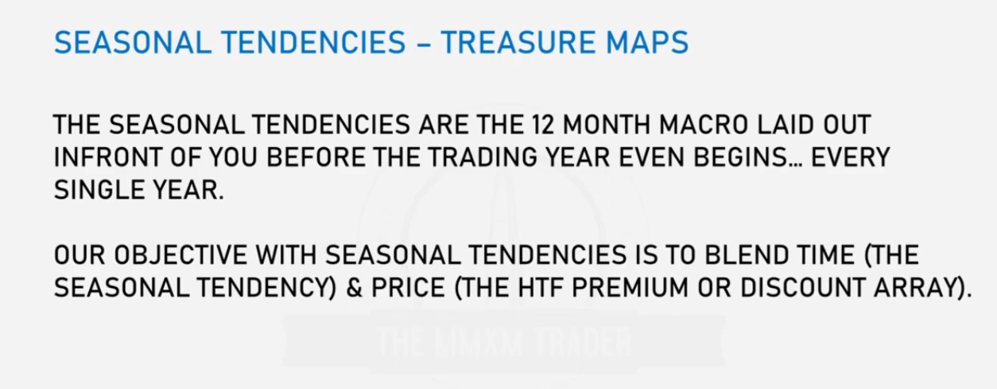

**Given**

Blue -- 33 year graph

Red -- 15 year graph

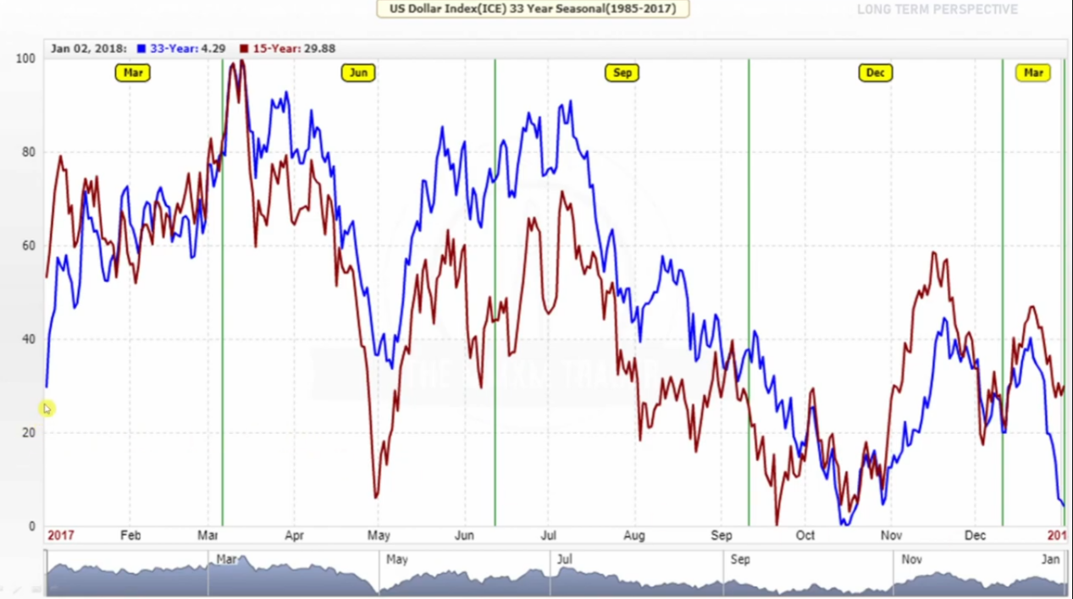

A **33-year or 15-year seasonal graph** is a specialized chart used in market analysis to study **long-term seasonal tendencies** in price behavior. These graphs are created by averaging price movements over a period of 33 or 15 years to identify recurring patterns or trends across the selected time-frame.

These graphs help traders and analysts understand how prices of a specific asset, index, or commodity typically behave during a given time of the year, based on historical data.

### ****Key Features of a 33/15-Year Seasonal Graph****

* **Averaged Price Movement:** The chart shows the average price movement for each day, week, or month over the selected 33 or 15 years.
* **Seasonality Focus:** Highlights recurring tendencies in price trends that occur consistently in certain months or seasons (e.g., price rallies in December or drops in May).
* **Long-Term Perspective:** Using longer historical data smooths out anomalies and provides a clearer picture of sustained seasonal trends.
* **Period Selection:** A **15-year graph** provides insights into recent seasonal trends, which may reflect modern market conditions.

A **33-year graph** incorporates a broader dataset, reducing the impact of short-term changes and providing more statistically robust insights.

### ****Applications of 33 or 15-Year Seasonal Graphs****

* **Identifying Seasonal Peaks and Troughs:** Spot times of the year when price is likely to peak or dip based on historical behavior.  
  Example: Gold prices often peak in January due to increased demand from global markets.
* **Planning Long-Term Strategies:** Investors can use these graphs to plan entry and exit points for long-term investments or swing trades.
* **Risk Management:**Helps predict periods of heightened volatility or price consolidation to adjust exposure accordingly.
* **Validating Seasonal Hypotheses:**Traders can confirm whether common seasonal tendencies (e.g., “Santa Claus Rally” or “Sell in May”) align with historical data.

### ****How These Graphs Are Made****

1. Gather historical price data for the selected asset over 33 or 15 years.
2. For each time unit (day, week, or month), calculate the average price or percentage change.
3. Plot the resulting averages on a graph to visualize the recurring seasonal trends.

### ****Example in Use:****

### ****Commodity Example:** 33-Year Graph for Corn:** Shows how corn prices rise in May (planting season) and fall in September (harvest season) almost every year, providing a clear roadmap for agricultural traders.

#### ****Forex Example:** 15-Year Seasonal Chart for EUR/USD:** Indicates that the Euro often strengthens in December due to year-end capital flows and weakens in the summer due to lower market liquidity.

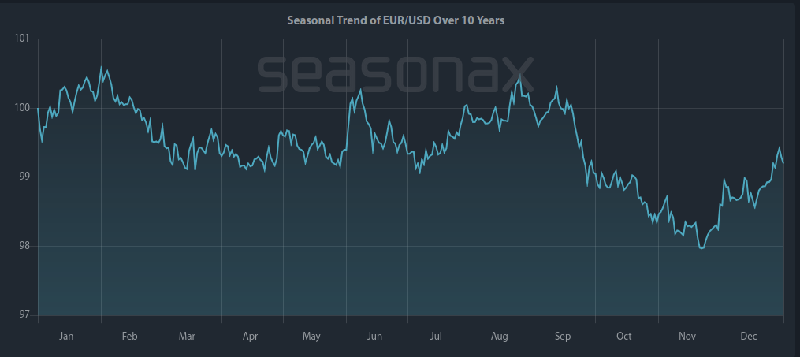

02 Jan- 03FEB

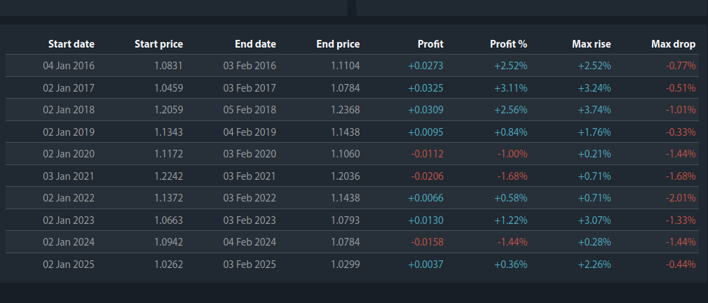

14TH march - 3rd june

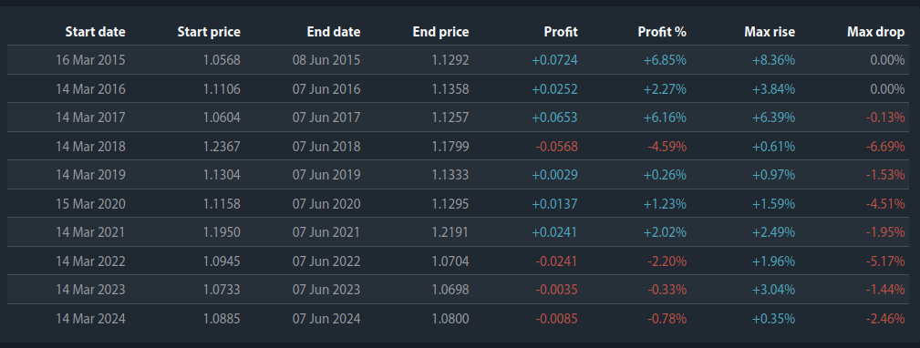

21st NOV to 29TH DEC

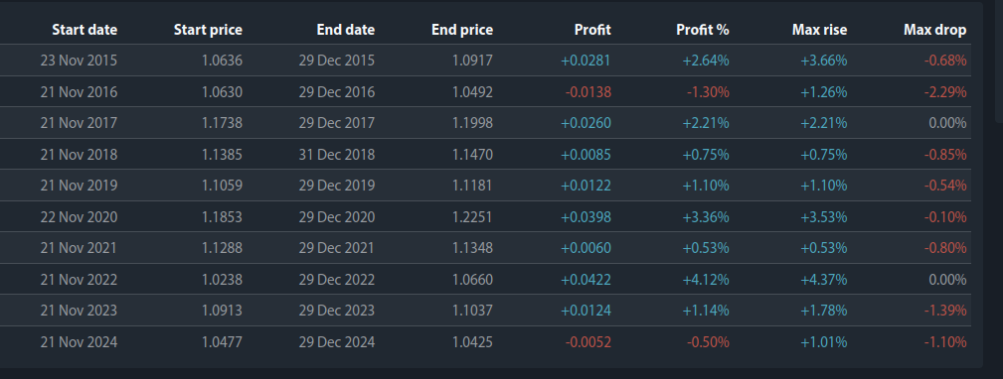

**LTP SEASONAL_ERL_IRL_HTF: EXAMPLE ONE**

Given a USD monthly chart

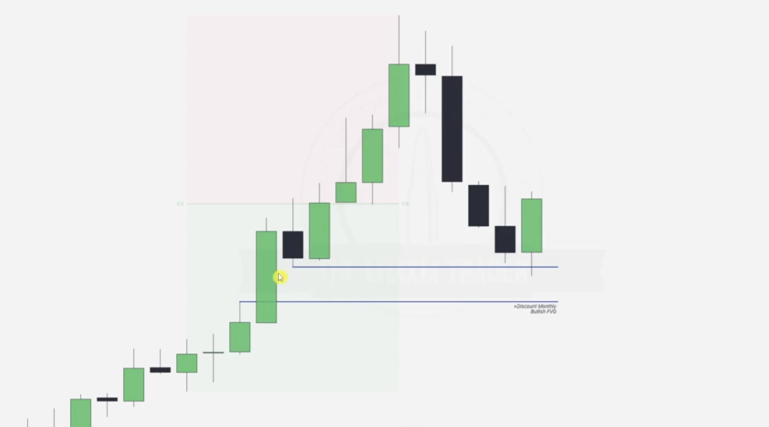

According to the 33-15 year seasonal graphs.. Jan and Feb are supposed to be bullish tendencies hence we wait for the point at which the monthly discount FVG is tapped.. btn JAN and FEB and anticipate a bullish trend after the tap.

Going to daily chart

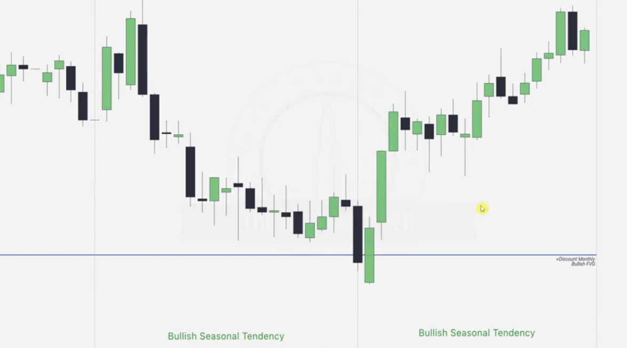

Note that in JAN before the tap, **we expected price to be bullish but there is lots of consolidation and some bearish trend since the seasonal trend doesn’t align with any discount array, but immediately it taps into the monthly discount array, we notice the bullish trend forming.. ALIGN WITH KEY LEVEL**

During the explosive move , there is a break (Daily FVG) formed, from which we can place our trades.. for HTF traders

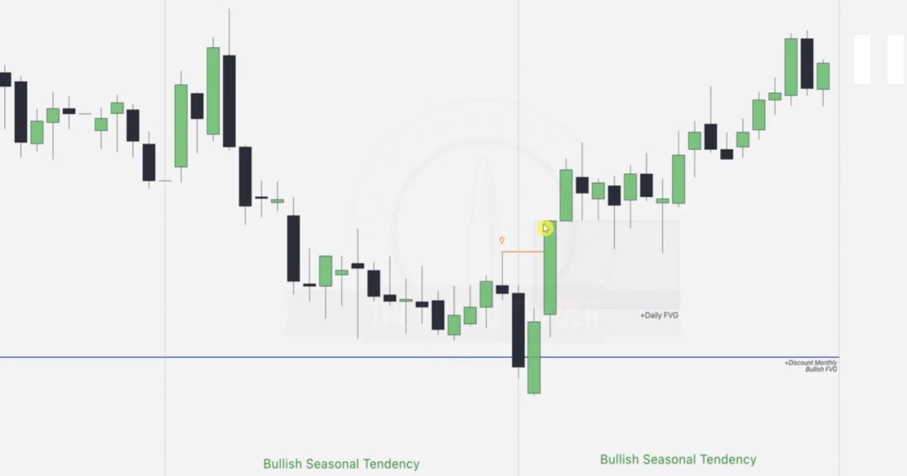

As shown in the previous slide, we can see that even though **January has a bullish seasonal tendency**, we don’t simply go long just because of that tendency. Instead, we need to wait for both **time (seasonality)** and **price (HTF array)** to align. When they do align, we can expect **explosive, one-sided price moves**, similar to what we see in **February**.

**LTP SEASONAL_ERL_IRL_HTF: EXAMPLE TWO**

Given a monthly Australian/USD chart

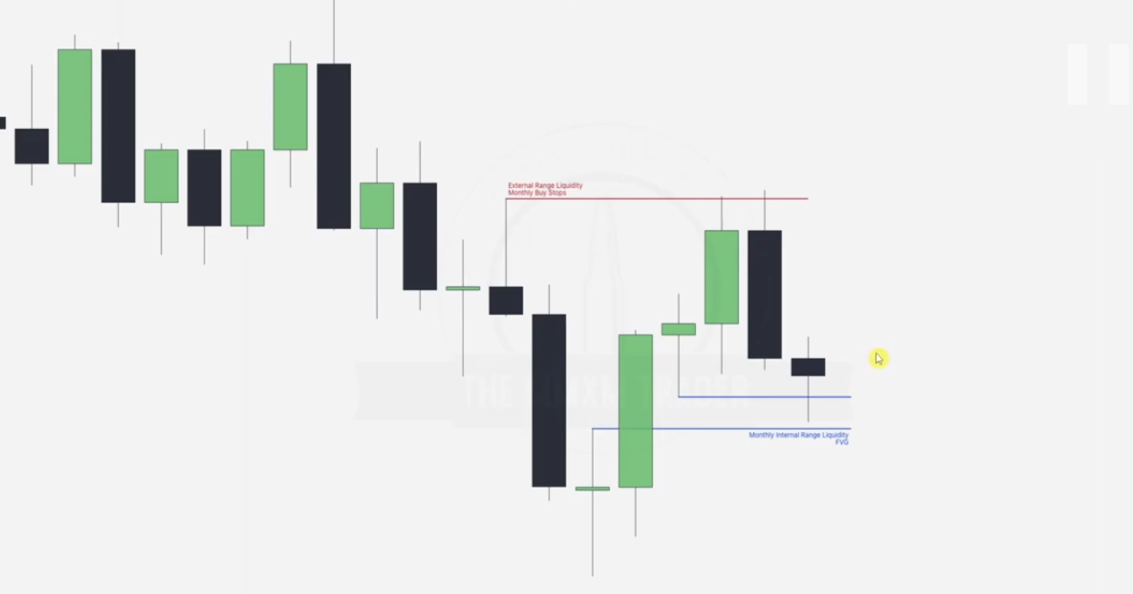

Note the ERL..IRL

We have a bullish JAN and FEB on DXY(USD)..**remember this is not EUR/USD** hence all foreign currencies should be bearish e.g Australian in this case

Going daily... we aim for alignment with a key ERL or IRL then predict either reversal or continuation

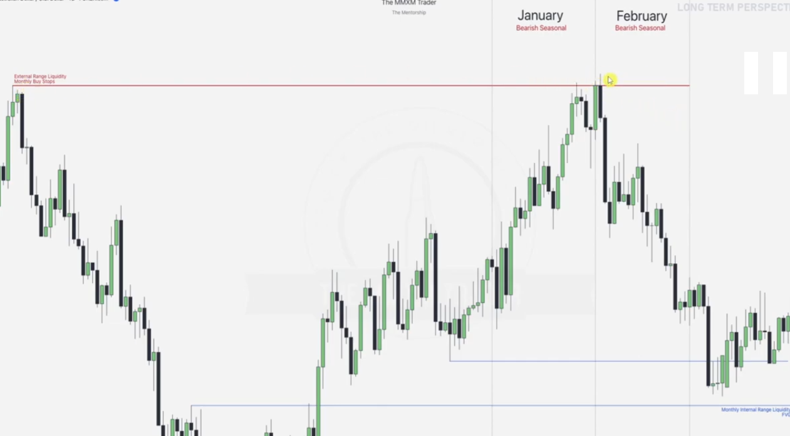

Note that once the premium HTF ERL level is hit, there is a reversal.. and an up-close candle is formed hence our Feb becomes highly bearish as expected.. this movement aims for the IRL of the discount FVG gap as illustrated.. ERL to IRL

Going into Feb analytics

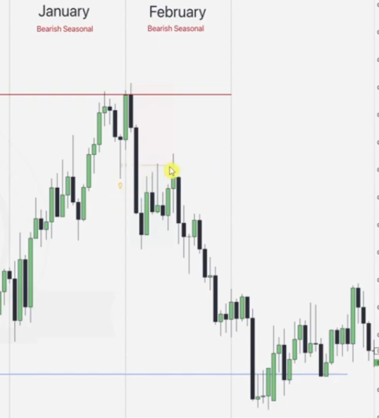

Draw the trading range prem_disc

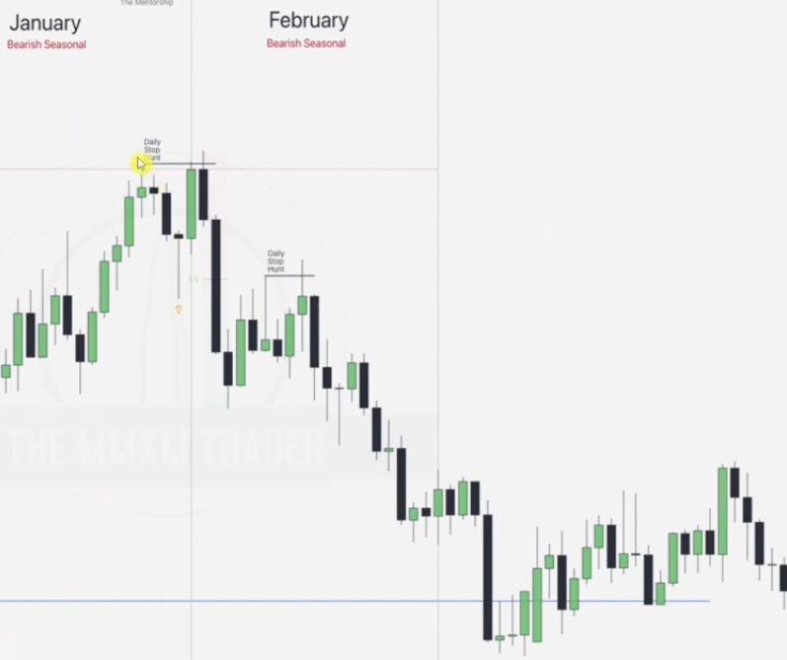

Note the stop hunts and draw STH and ITH based on the silver bullets

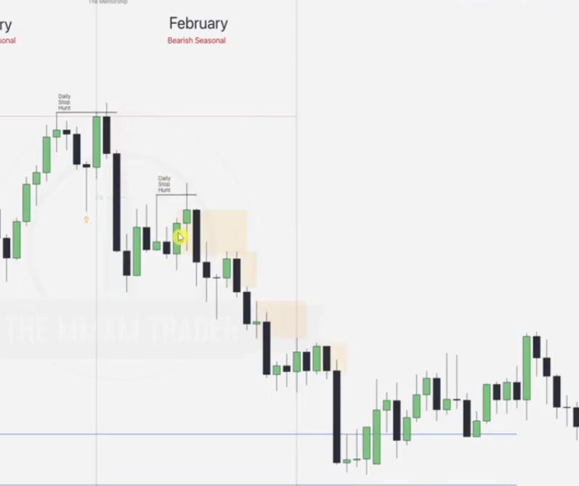

Note the up-close candles.

**LTP SEASONAL_ERL_IRL_HTF: EXAMPLE THREE**

Given Monthly chart

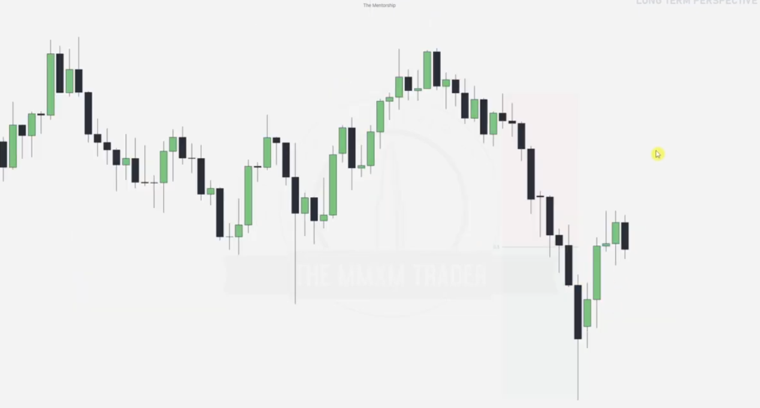

We draw the mitigation/ breaker block as indicated and its ERL.. buy stops

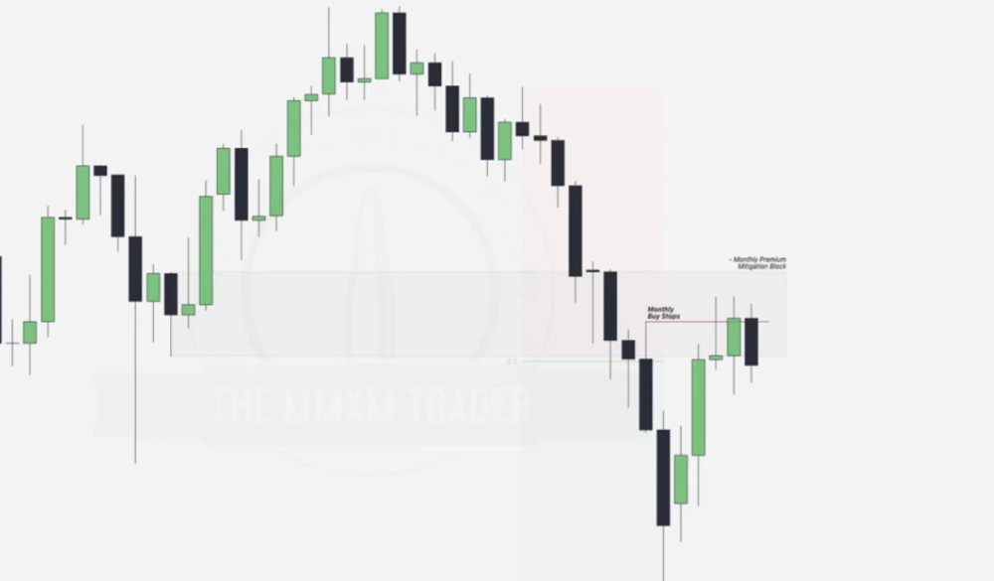

Note that where DXY is bullish, USD is bearish and vice versa

*Introducing SMT*

**SMT (Smart Money Technique)** is a concept in trading, particularly popularized within the **ICT (Inner Circle Trader)** framework. SMT involves analyzing the behavior of **related markets, pairs, or indices** to identify divergences, which can signal potential reversals or continuations in price movement.

### ****Key Elements of SMT****

**Divergence Between Related Assets:** SMT focuses on comparing price action between two or more correlated assets or instruments, such as:

* Forex pairs (e.g., EUR/USD vs. GBP/USD)
* Indices (e.g., S&P 500 vs. NASDAQ)
* Commodities (e.g., Gold vs. Silver)

A divergence occurs when:

* One asset makes a **higher high**, while the other fails to do so, signaling a potential reversal.
* One asset makes a **lower low**, while the other does not, suggesting a change in market sentiment.

**Bullish SMT Divergence**

Occurs when: **One correlated asset creates a lower low**, while another correlated asset **fails to create a lower low**. This indicates **accumulation** (smart money buying) and a potential bullish reversal. **Example**: EUR/USD creates a lower low while GBP/USD does not create a lower low. This suggests that smart money may be positioning for a bullish move on the EURO/USD.

**Bearish SMT Divergence**

Occurs when:**One correlated asset creates a higher high**, while another correlated asset **fails to create a higher high**. This indicates **distribution** (smart money selling) and a potential bearish reversal. **Example**: NASDAQ creates a higher high and S&P 500 does not create a higher high. This suggests that smart money may be positioning for a bearish move.

**NB: Combine With Other ICT Concepts:**Use SMT with **order blocks**, **fair value gaps (FVGs)**, and **liquidity pools** to improve accuracy.

### ****Example SMT Setup****

**Scenario**:

* EUR/USD makes a lower low, sweeping liquidity below a key level.
* GBP/USD fails to make a lower low, holding above a previous support level.
* **Interpretation**: Smart money is likely accumulating in GBP/USD for a bullish move.
* **Action**: Enter a long position on GBP/USD, aligning with other confluences like order blocks or FVGs.

The chart we were using was for GBP/USD, hence when looking at the EUR/USD, higher high was made while GBP/USD failed to create a higher high hence pointing to potential reversal on our side here GBP/USD

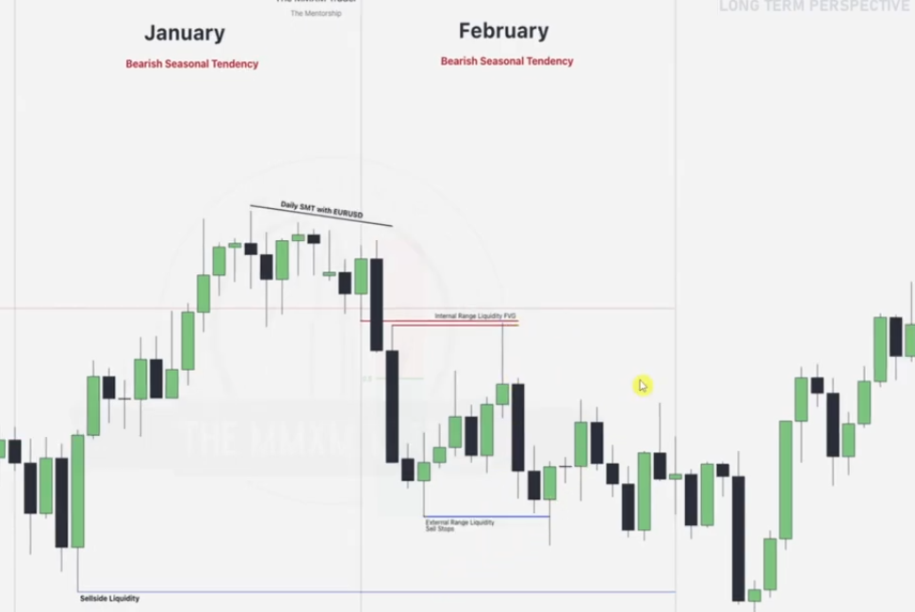

After predicting reversal using SMT, note formation of the FVG and apply Silver bullet and ERL.. IRLs concepts

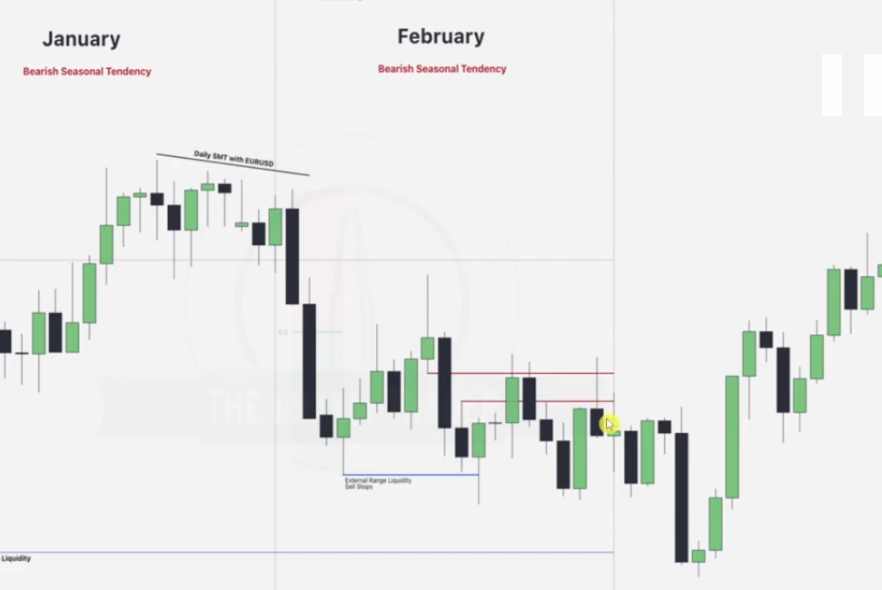

**LTP SEASONAL_ERL_IRL_HTF: EXAMPLE FOUR**

Given monthly chart

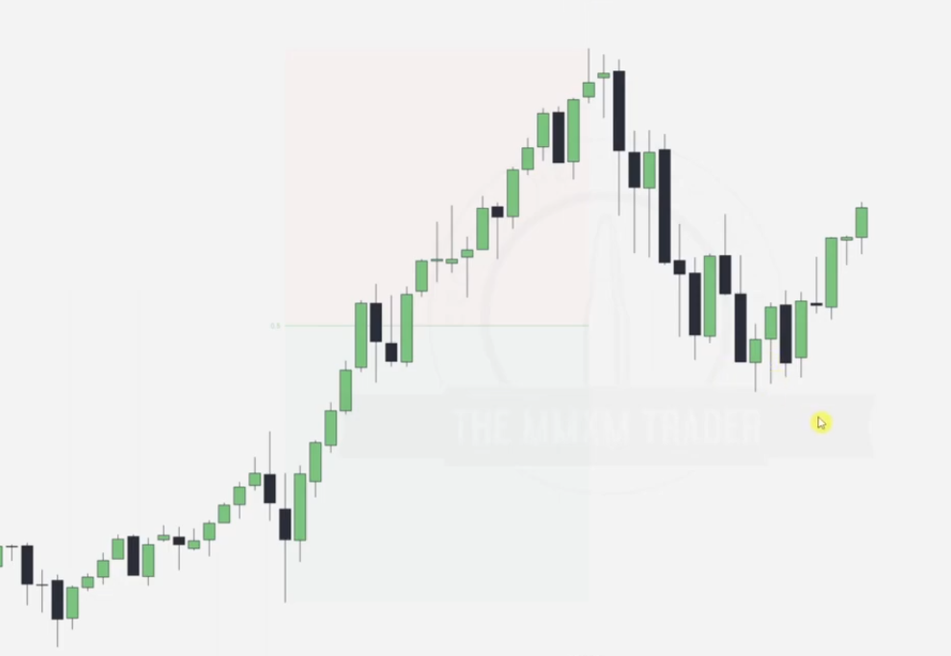

Draw the ERL..IRL to determine where market is going

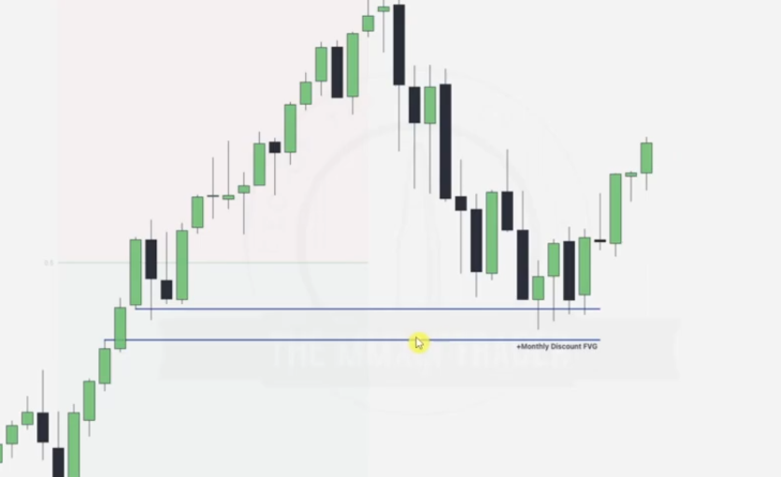

IRL

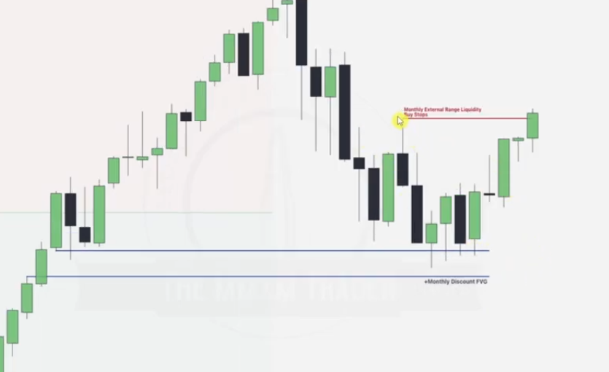ERL

Going to weekly chart, so we can go ERL vs IRL all the way

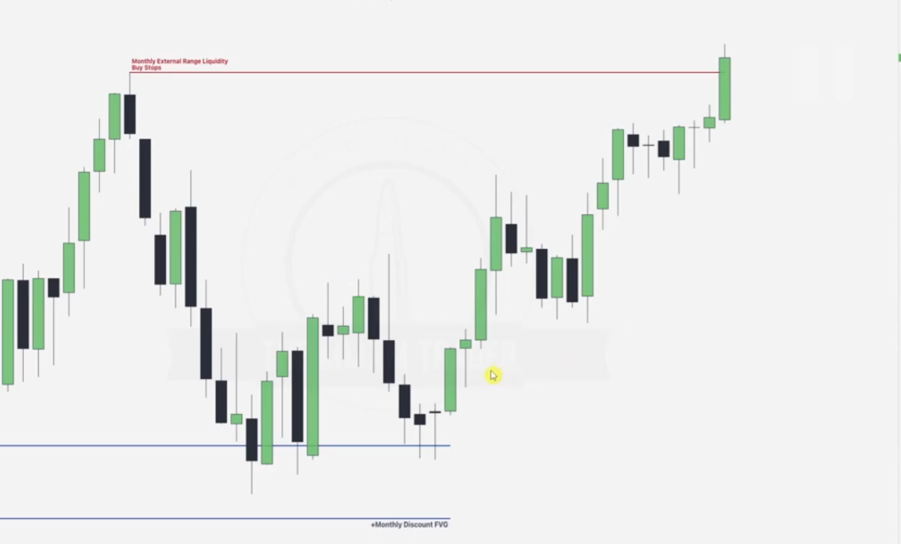

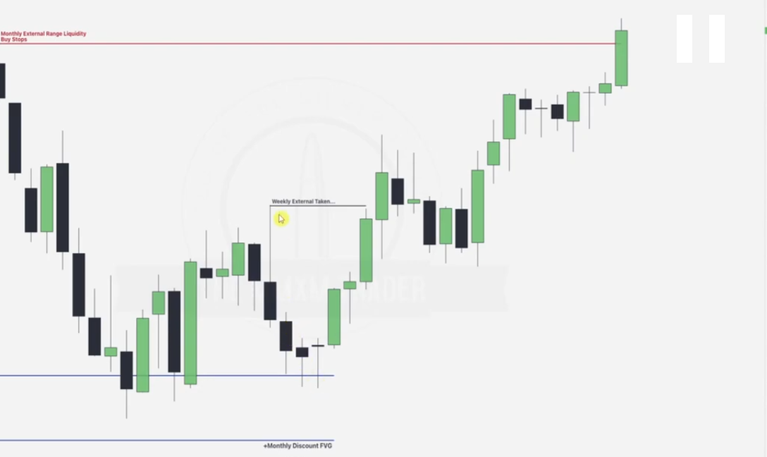ERL

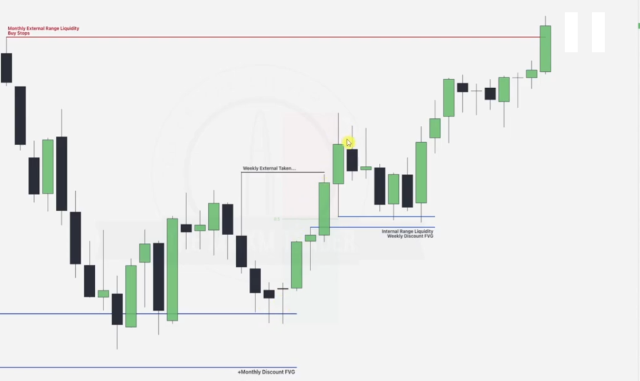

IRL

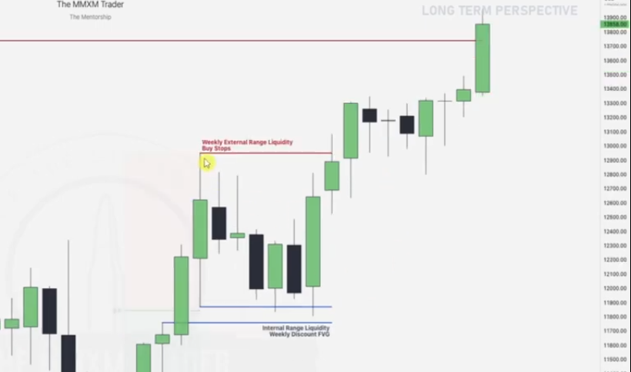ERL

And onwards

**LTP SEASONAL_ERL_IRL_HTF: EXAMPLE FIVE**

Given daily chart... SOMETIMES WHEN MONTHLY AND WEEKLY CHARTS ARE UNCLEAR WE GO DAILY

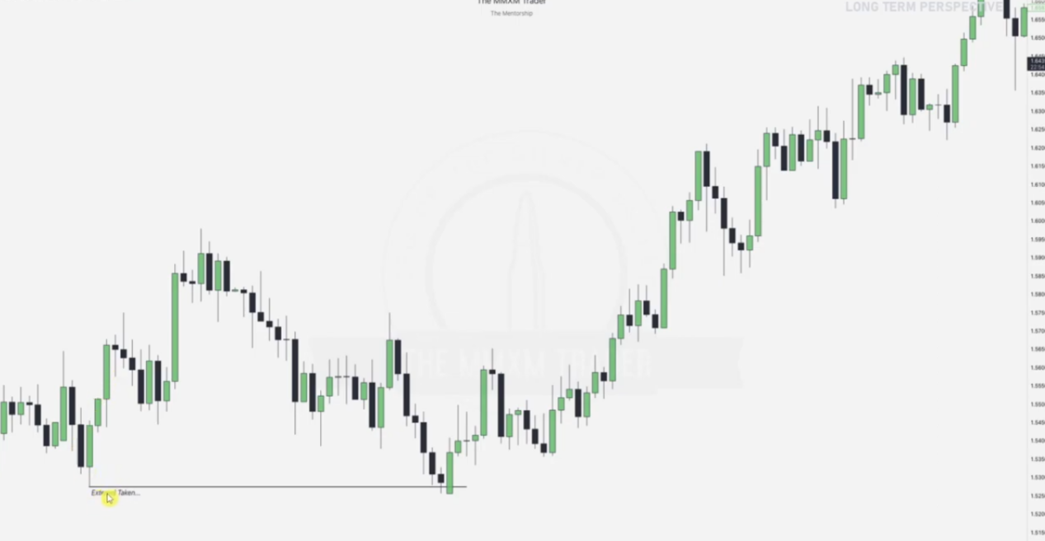

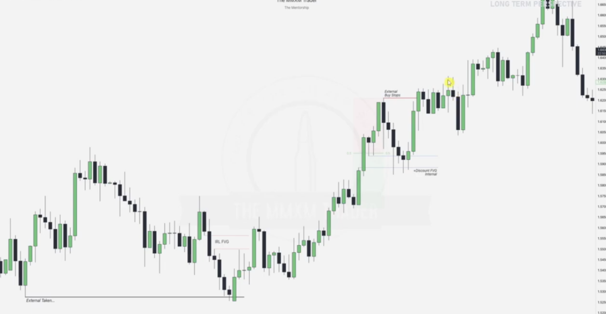Draw ERL vs IRLs based on your perspective... THIS IS WHEN YOU HAVE FAILED TO GET MONTHLY WEEKLY SEASONAL etc.

**INTERMEDIATE TERM PERSPECTIVE(H4 AND H1 CHARTS)**

**Intermediate Term Perspective (ITP) – H4 & H1**

The **Intermediate Term Perspective (ITP)** provides the answer to:  
**"How should price get to the Long Term Perspective (LTP) draw on liquidity?"**

* **LTP** = Why price should go to a specific price level.
* **ITP** = How price will get to that specific price level.

### **Market Structure** and **PD Arrays** on this time frame are used to guide price to the LTP liquidity draw. The **highest probability trades** occur when both the **LTP** and **ITP** order flow are aligned.

**Intermediate Term Perspective (ITP)-- steps**

* **Starting Point**: All analysis begins with identifying the **draw on liquidity**, which is determined from the **LTP time-frames** (monthly, weekly, or daily analysis).
* **Next Steps**:Once the **HTF (higher time-frame) weekly or daily draw on liquidity** is determined, the focus shifts to the ITP time-frame. Wait for the **ITP time-frame** to **break market structure** in the direction of the LTP draw.
* **Goal**: Align the **LTP (long-term perspective)** and the **ITP (intermediate-term perspective)** to ensure coherence in market direction.

### ****Intermediate-Term Perspective****

To align with the **weekly trend**, we use:  
✅ **Draw on Liquidity (DOL)**  
✅ **Premium & Discount Arrays** (as determined by the **long-term perspective**)  
✅ **Weekly Candlestick Patterns** – focusing on **Open, High, Low, Close (OHLC)**

#### ****Steps to Determine the Weekly Profile:****

* ️⃣ **Identify the Weekly Profile:** Use past **weekly profiles** to predict the most likely scenario for the current week.
* ️⃣ **Check the Economic Calendar:** Identify **high-impact news events** that may cause volatility.
* ️⃣ **Find the Key Volatility Days:** Focus on days with potential **large price movements** based on news or liquidity injections.

**INTERMIDIATE TERM PERSPECTIVE: EXAMPLE ONE**

Given a weekly chart

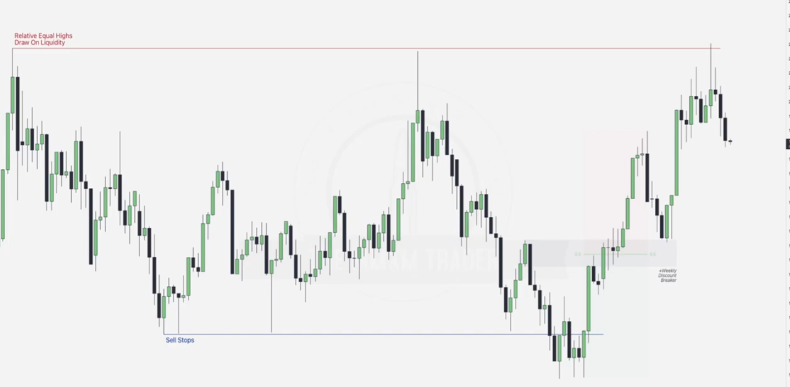

We have drawn our LTP BSL(equal highs-red)and SSL(Order pairing), then the breaker block(grey).Now next step is to jump to ITP and check for high probability alignments with the LTP.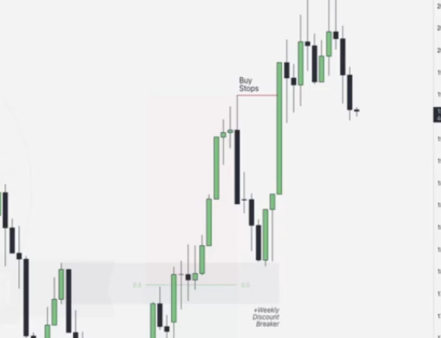

Remember that from the breaker our next stop is the ERL as illustrated

**ITP NOW:** Going to the 4 hrs chart, we will look for a break in structure.. in this case especially after the order pairing

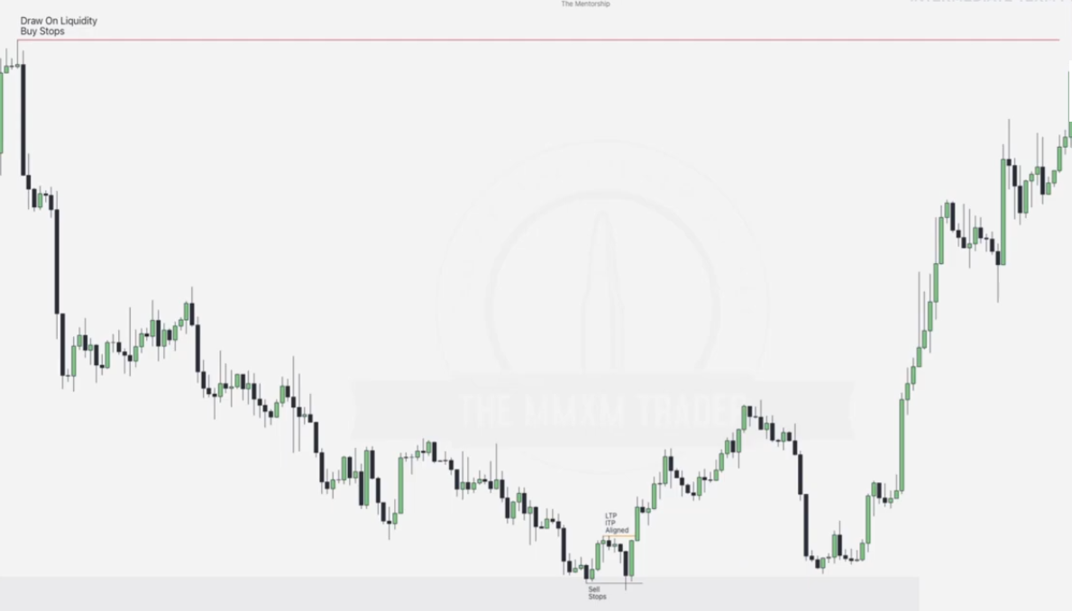

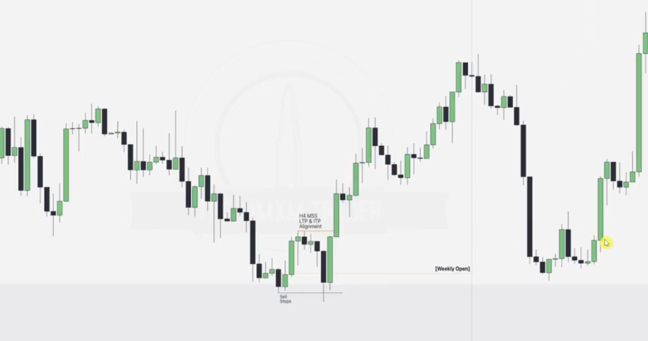

* We note that there is a break in structure as illustrated by FVG above hence confirm that LTP and ITP are aligned, hence we prepare for some bullish action.
* We draw our weekly open..we want to know in which day of the week we are trading higher and lower, we can align this with high impact news.

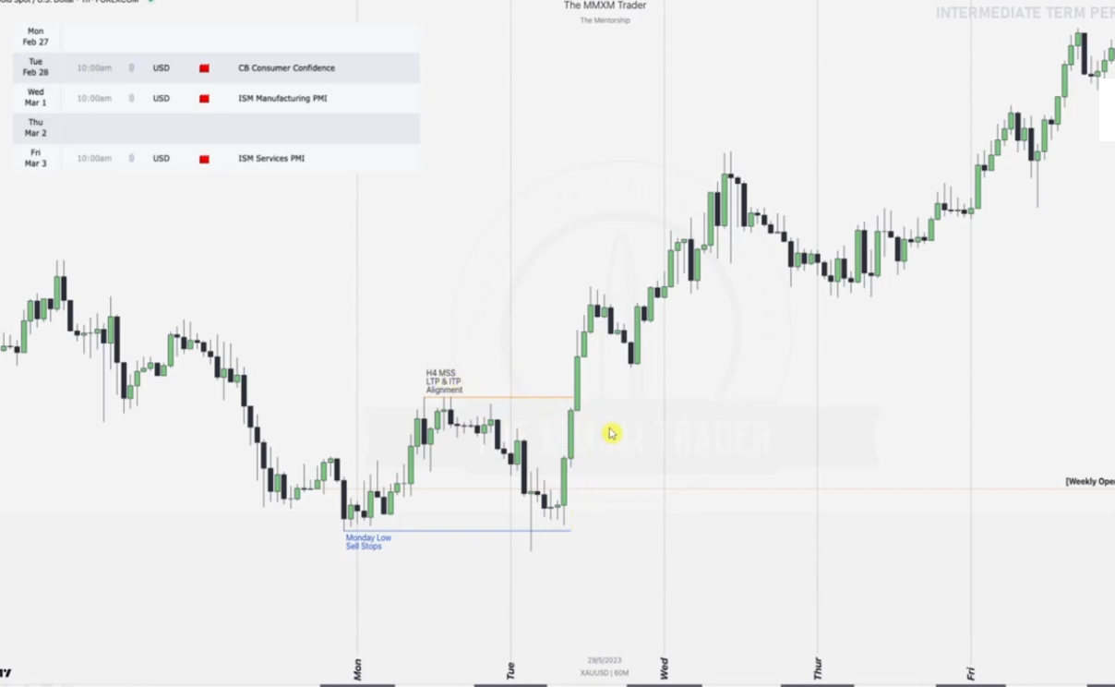

Note:

* Monday we have no news hence there is accumulation of price within its daily range(here we are on 4hr chart)
* Tuesday, we have high impact news.. consumer confidence.. as a result there is **manipulation** of Monday’s low which is taken to form the low of the week.. and since Monday was accumulation, Tuesday (AMD), after manipulation there is distribution.. expansion as illustrated. LTP and HTP is also aligned on Tuesday

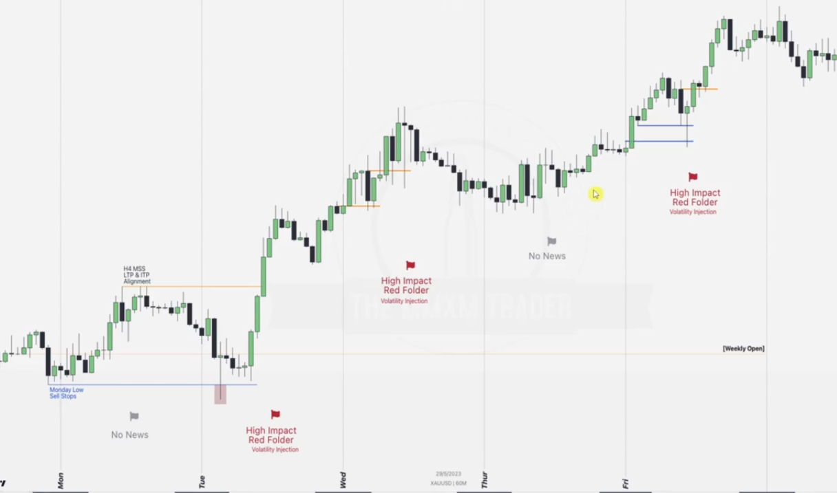

* Wednesday we have high impact news hence we expect continuation in the order flow of the LTP
* Thursday there is no news hence we expect consolidation.. same as on Monday
* Friday there is high impact news hence we expect continuation in the LTP.. hunting for the LTP draw.

Going back to the weekly to spot some more ERL..IRL action

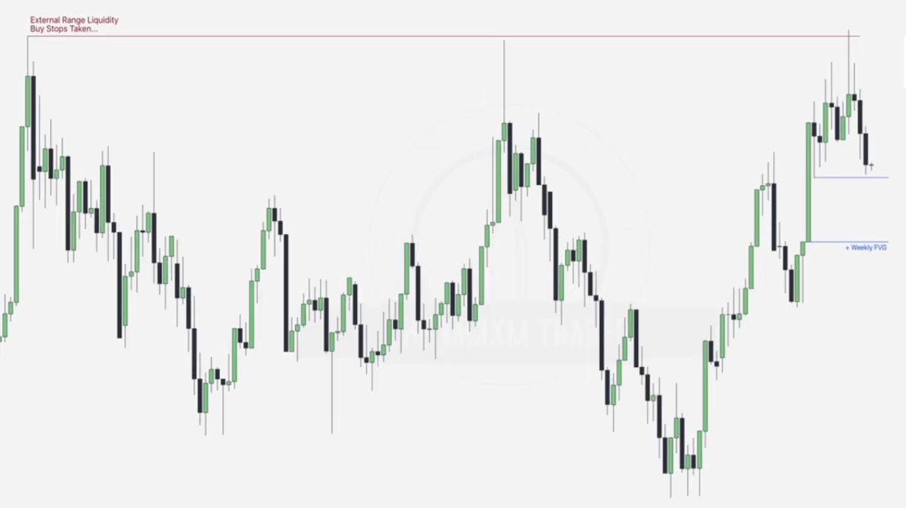

* Note that after the LTP buy stops draw is taken, we could have expected a bullish continuation but there is a counter trend which is bearish in the ITP hence we go for ERL to IRL.. The FVG formed as above
* We go to the 4hr structure to confirm the trend, by checking for a MSS(Market structure break)

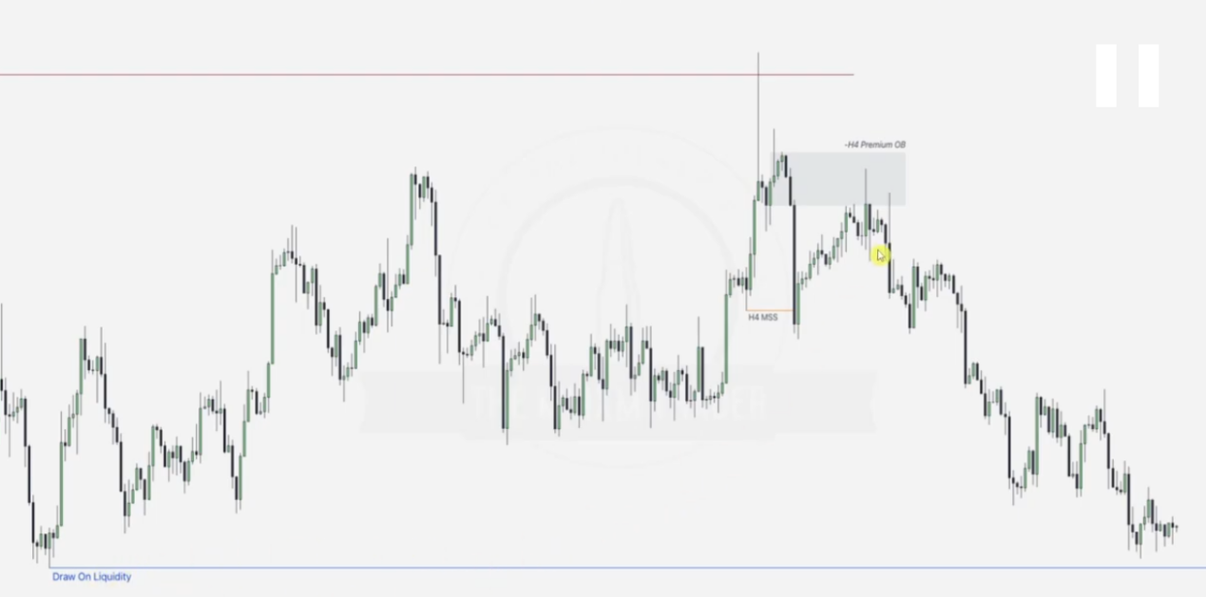

* MSS is noted and we see a high probability Order block(up-close) formed which will provide rejection towards draw of the weekly SSL
* Noting down the news in this week

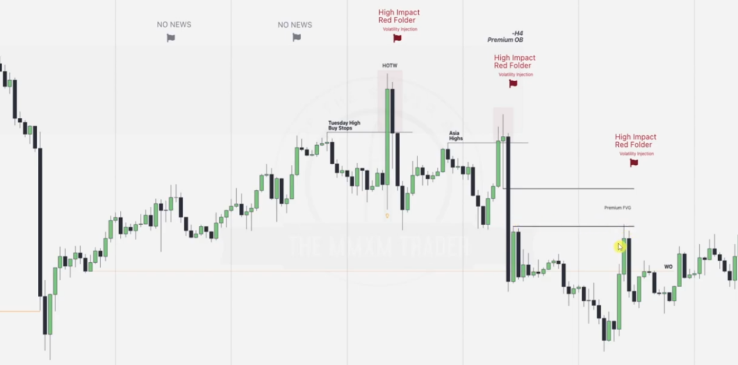

Monday and Tuesday have no news hence we expect consolidation, however high impact news on Wednesday causes formation of high of the week because trend is bearish.. note that the best entry in this point is when this is aligned with the premium order block(this OB should also be at key level.. which in this case is the aligned Buy stop).. also check the silver bullet setup formed as a result

**WEEKLY OPEN**

The purpose of drawing a **weekly open** on a chart is to establish a key reference point that helps traders understand market sentiment, direction, and potential price behavior for the week. Here's why it’s important:

### ****1. Key Reference Level for Bias:**** The weekly open acts as a **benchmark** to identify whether price is trading above (bullish bias) or below (bearish bias) the weekly opening price.

### ****2. Intra-day and Swing Trading Context:****For intraday traders, it provides a framework to align trades with the **weekly trend**. For swing traders, it helps in identifying whether the current week's price action supports their longer-term analysis.

### ****3. Liquidity and Market Structure:****Institutional traders often use the weekly open as a liquidity target. Price may revisit the weekly open to grab liquidity or test it as a support/resistance zone.

### ****4. Reversal and Continuation Signals:**** If price consolidates around the weekly open, it may signal potential **reversals** or **directional continuation** based on price reaction.

### ****5. Alignment with Higher Timeframe Analysis:**** Combining the weekly open with **monthly**, **daily**, or **hourly** opens helps create a multi-time-frame strategy, ensuring better alignment with the overall market structure.

SHORT TERM PERSPECTIVE

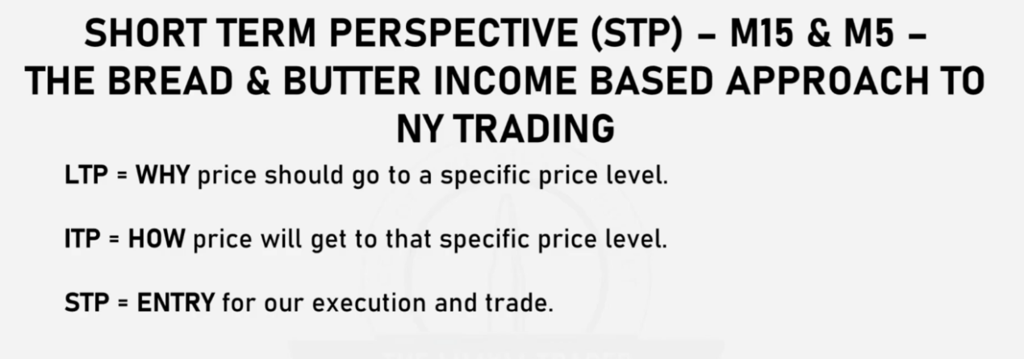

Using EST

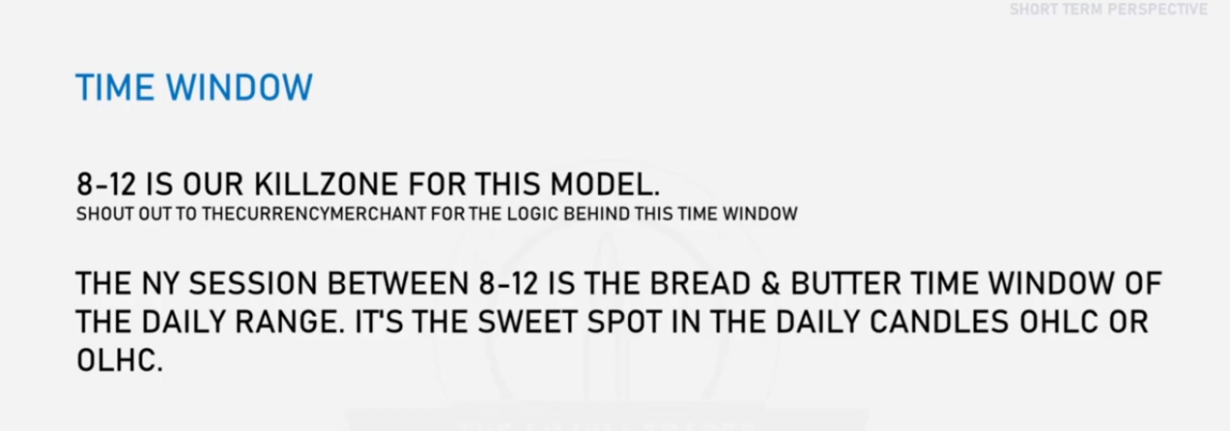

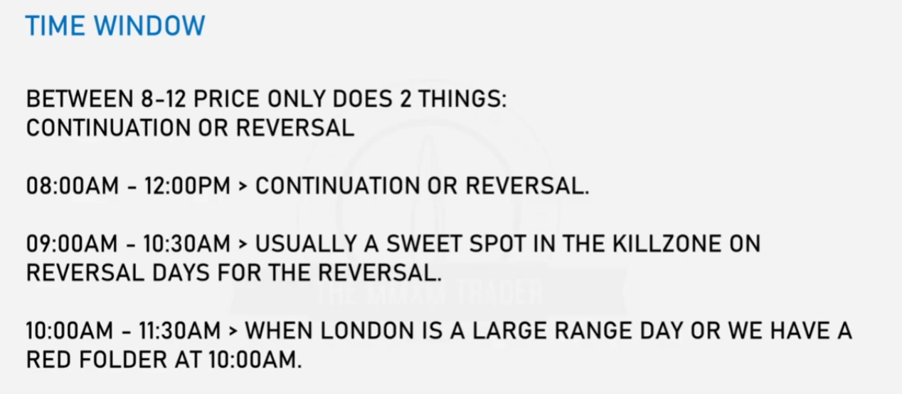

### ****8:00 AM - 12:00 PM**:** During this period, the market typically performs **one of two actions**:

### **Continuation**: The price extends in the direction of the existing trend.

### **Reversal**: The price moves against the trend, signaling a shift in market direction.

### ****Specific Timeframes and Their Behaviors:****

#### ****08:00 AM - 12:00 PM:**** This time window is critical for observing whether the market **continues its prior trend** or initiates a **reversal**.The early part of the session often sets the tone for the day’s price movement.

#### ****09:00 AM - 10:30 AM:**** This is referred to as the **“sweet spot”** for reversals, especially on days when a reversal is expected. It aligns with the **Killzone** concept, which represents periods of high activity or potential turning points.Traders often look for price action setups, such as: Failure to break key levels, Shift in order flow.

#### ****10:00 AM - 11:30 AM:** 10:00 AM** is highlighted for significant market moves: When the **London session** has already experienced a large range, this time may signal **retracements** or **extensions**. If a **red folder event** (high-impact economic news) is scheduled at 10:00 AM, this period often experiences heightened volatility. Price movements during this time provide clarity on whether the market will **consolidate, continue, or reverse**.

**Why This Period(8-12) Is Important**:

It coincides with the overlap between the **London session** and the start of the **New York session**, which are the two most liquid trading sessions. High volume and volatility during this period provide opportunities for both trend-following and counter-trend trades.

**How to Use This Information**:

* Observe the market structure leading up to these times to determine whether a continuation or reversal is more likely.
* Use **higher timeframe analysis** (e.g., H4 or daily charts) to establish the bias, and fine-tune entries on lower timeframes (e.g., M15 or M5) during these windows.

**Red Folder Events**:

* Red folder events refer to significant economic news that can cause sharp price movements (e.g., employment reports, central bank announcements).
* Pay close attention to the time around these events, as they can lead to large, often unpredictable moves.

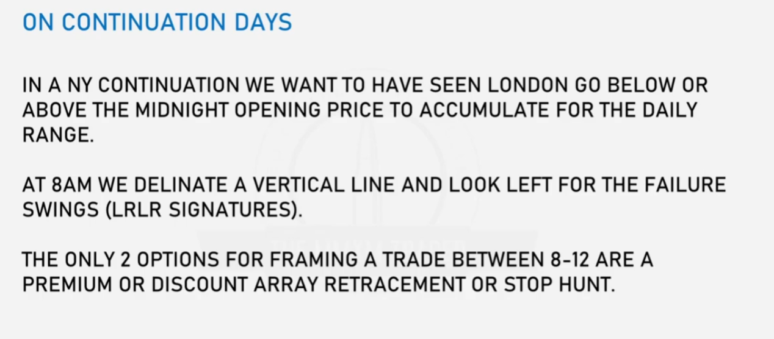

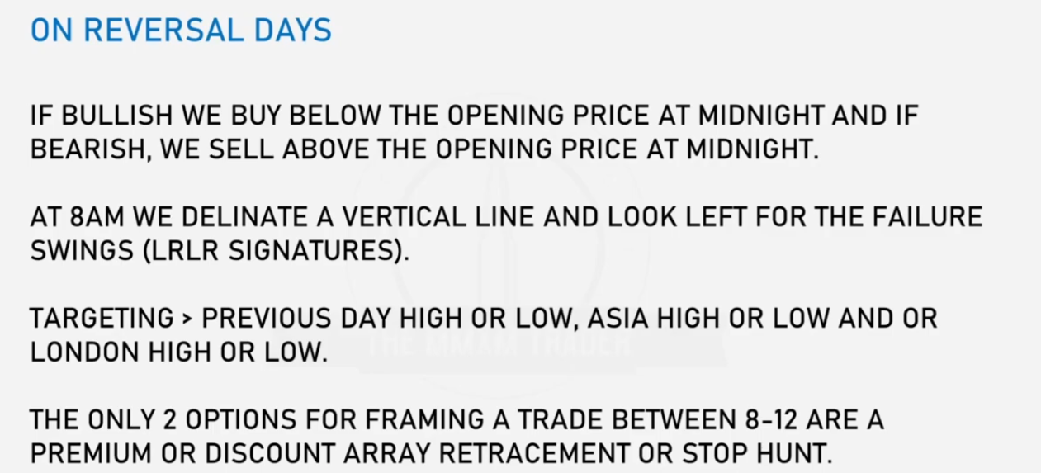

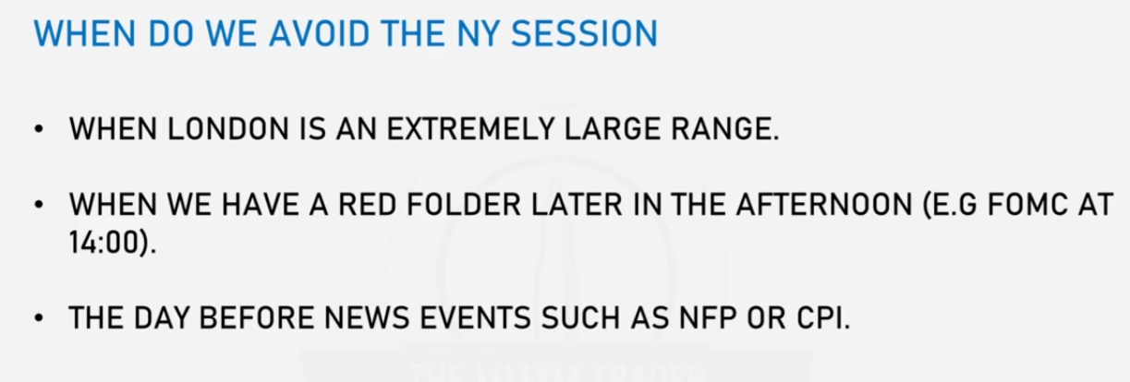

If london session is large, NY session might consolidate and be unpredictable

**NY CONTINUATION**

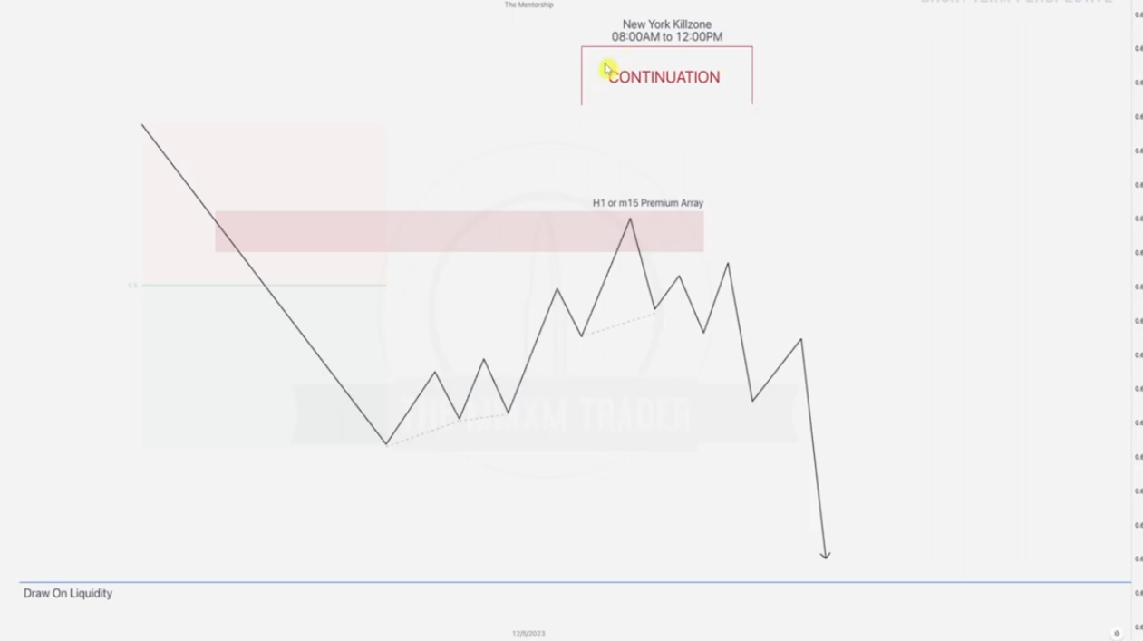

**Using PD array as target**: Draw the prem_disc and determine that a premium PD array is formed, this is the PD array targeted in the NY session: At 8AM note and monitor the Failure swings as labeled above

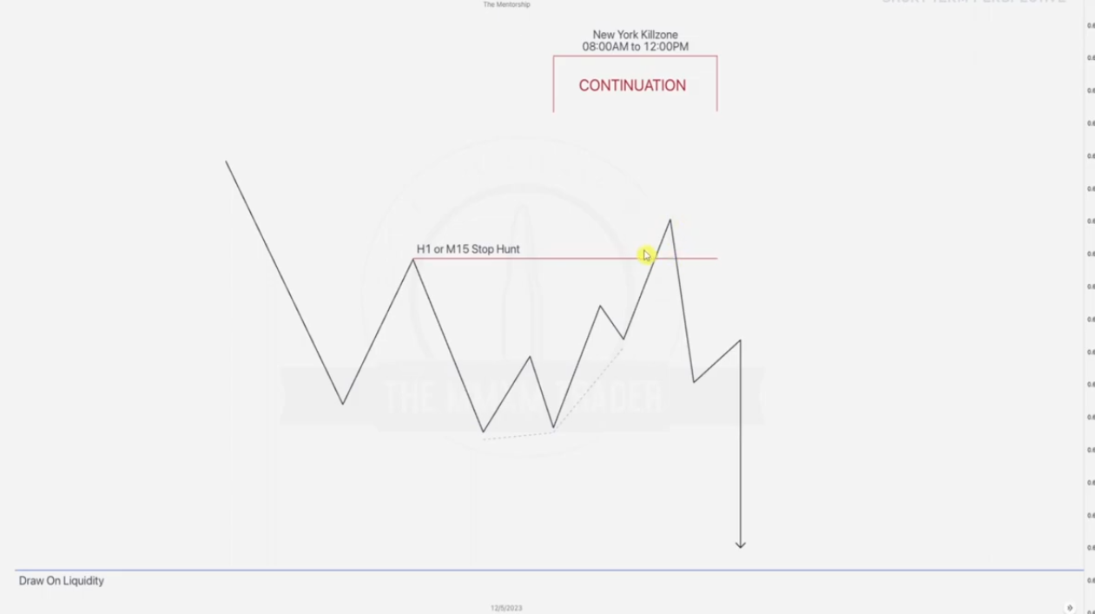

**Using stop hunt as target**:At 8AM Label the Failure swings(low hanging fruit) and note the order pairing as the cursor points

**NY REVERSALS**

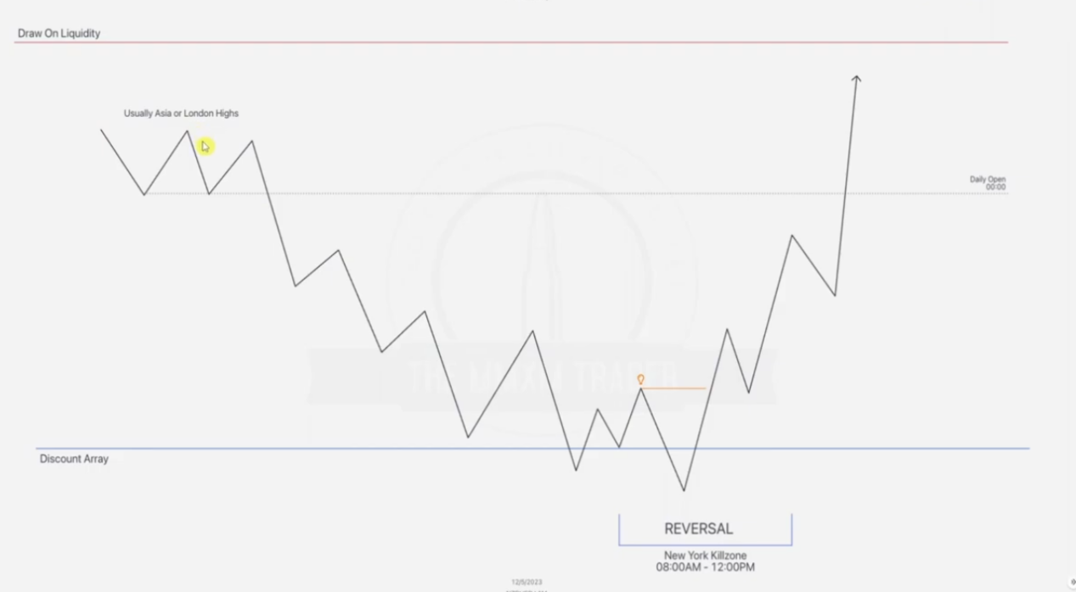

Above given is MMBM

Determine the original consolidation .. at cursor and it will determine the high of the day.. trade(in asian or london.. mostly london)

Draw the midnight open, we want to buy below and sell above it.

Note that the reversal is in line with the discount PD array formed at some point. Always look for the break in structure.

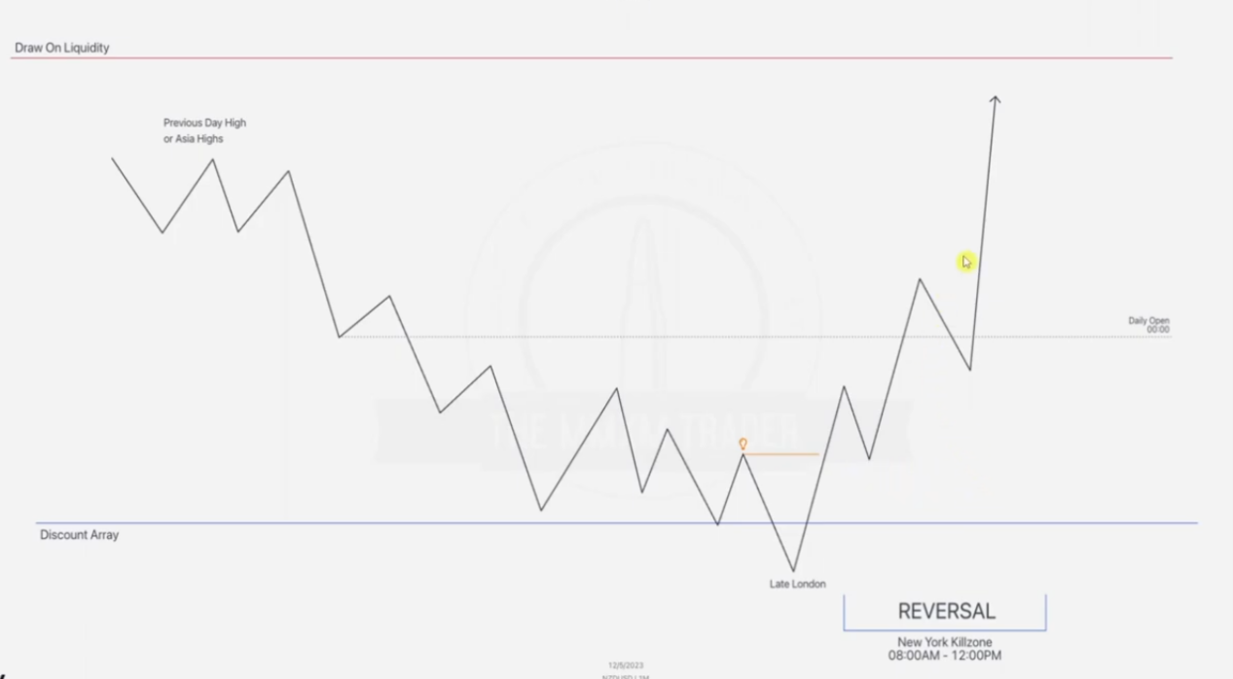

In this extract there is a second scenario where discount PD array is hit before the NY session , hence break of structure is already done. This is ok, we only continue looking for sweetspots to enter the trade in NY session to follow up with the bias.

**EXAMPLE 1(STOP HUNT + NY KILLZONE CONTINUATION)**

**Given 15 minute chart**

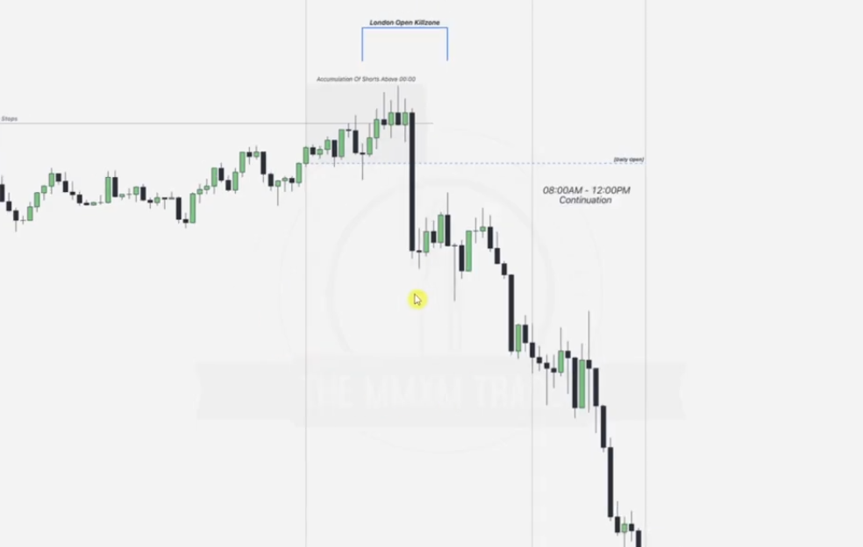

We label the vertical lines btn 00:00 and 00:00 to mark our day.

Draw our midnight open.. horizontal. You will note that accumulating of stops (order pairing ) occurs above the midnight open... at the London session to create the high of the day.. after the order pairing we wait for the break..

Draw the 8AM vertical line and note the LR LRs .. Failure swings these help you determine the ERL.. expecting downward continuation.. this can be confirmed by hitting a premium retracement , hitting a stop hunt etc

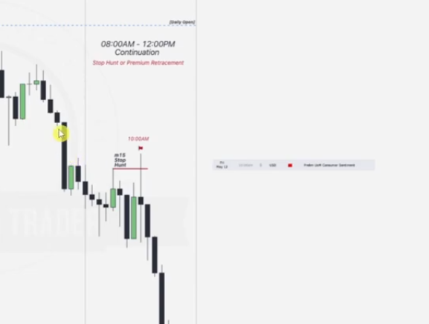

Wait and confirm if there is any news btn 10 am and 1130 am. If there is news this is a sweetspot for entry, if not we can start our markings at 8am. From this example we have news at 10 am, this causes a stop hunt to be taken as above(manipulation) before the distribution begins

Going to the 1 minute chart

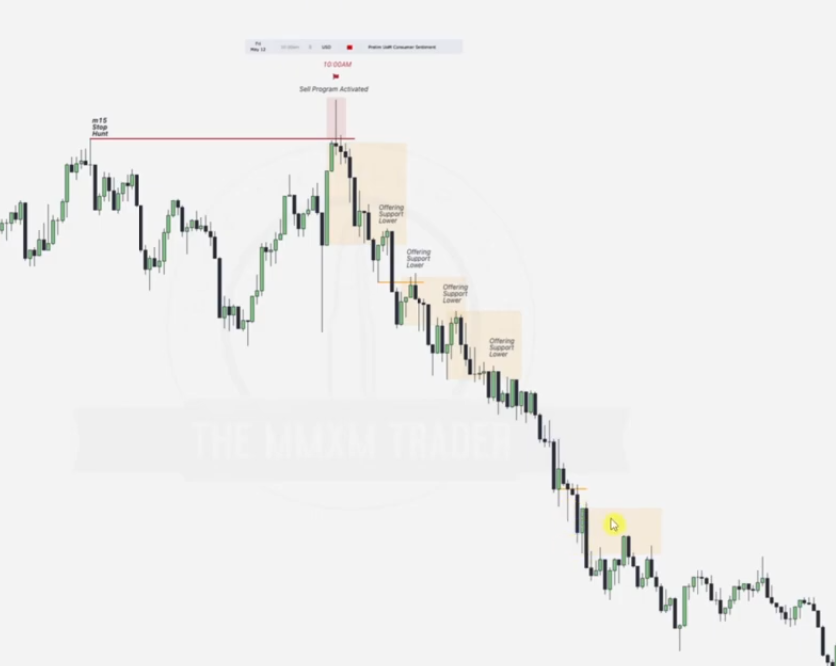

Note the sell program activation(order pairing) and wait for a break in structure.

Also note the STHs and ITH.

Best part here is noting that the up_close candles will all support price lower because we are in the 8-12 NY AM continuation and news has already spiked a stop hunt, even entry in the first order block above is permitted.

**EXAMPLE 2(PD ARRAY + NY KILLZONE CONTINUATION)**

**Given a 5 minute chart**

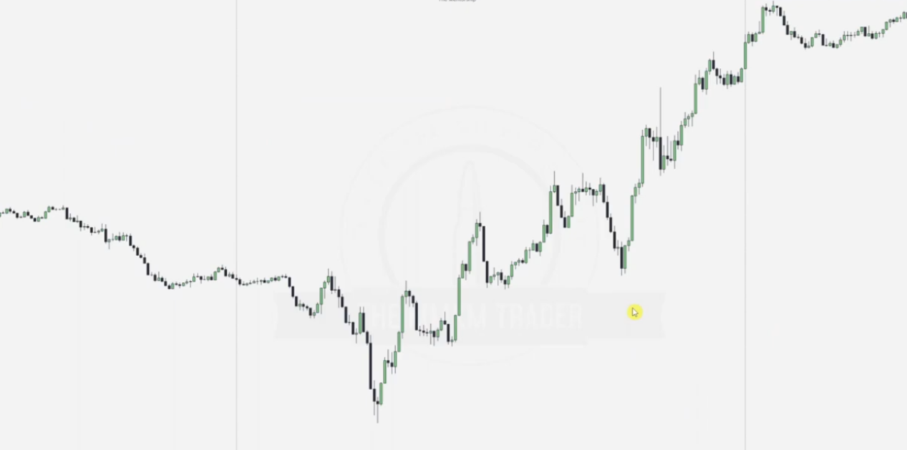

Draw the 00:00 vertical lines to mark the day.. midnight open horizontal line and label the london session.

Draw the 8AM vertical line and note the LRLRs .

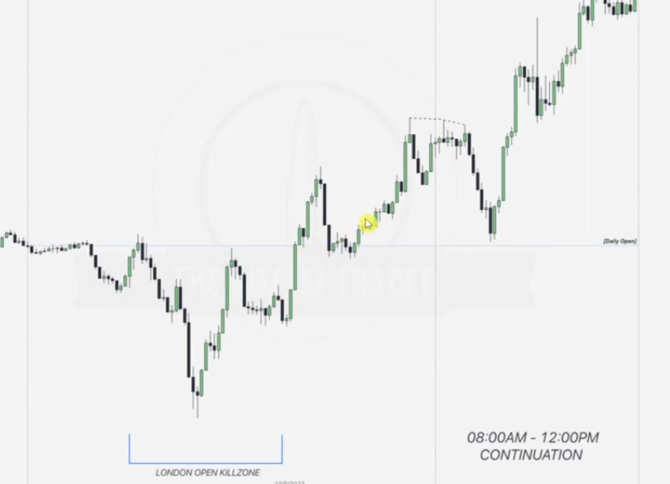

Next step is now finding either a stop hunt.prem_discount PD array being tapped into for order pairing in the opposite direction.. in form of retracement.

From here we note that there is a discount FVG that can be tapped into.

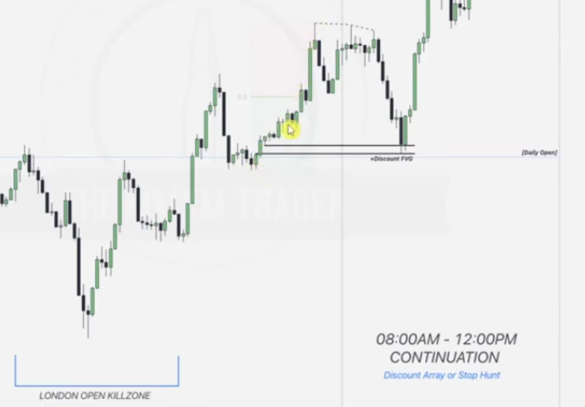

Draw the dealing range prem_disc.. order block noted at this point can be used as an entry point

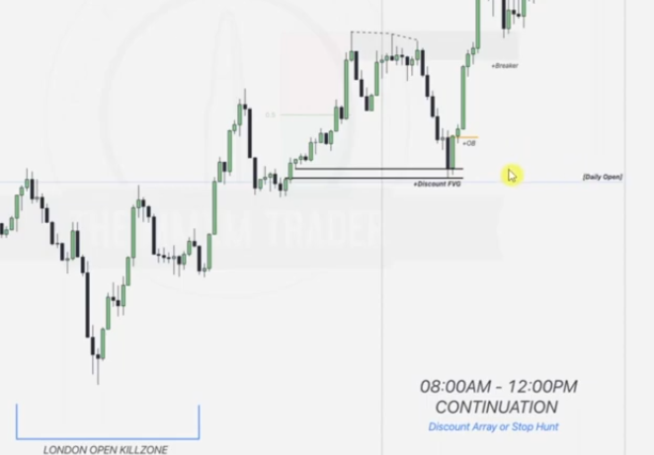

But also note that the first LRLR forms a breaker block after its resistance level was broken hence we can also make an entry from this point.

**NY REVERSALS**

EXAMPLE ONE(STOP HUNT + REVERSAL)

Given hourly chart

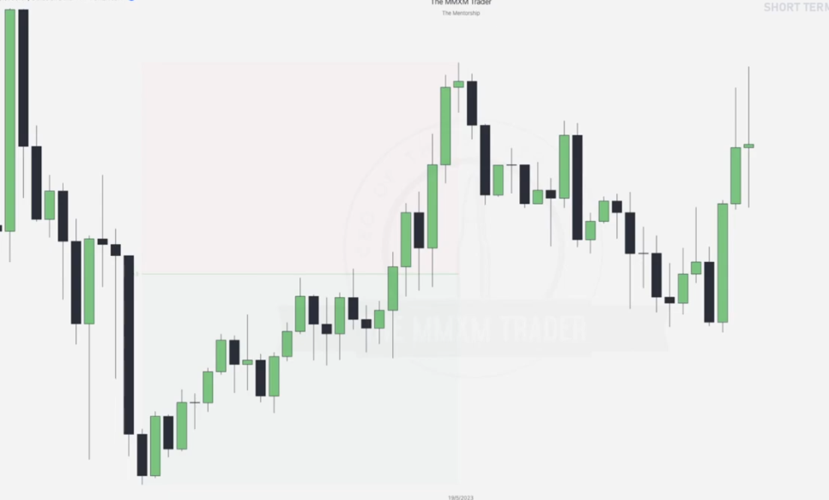

Draw the discount_premium chart and note the stop hunt as below

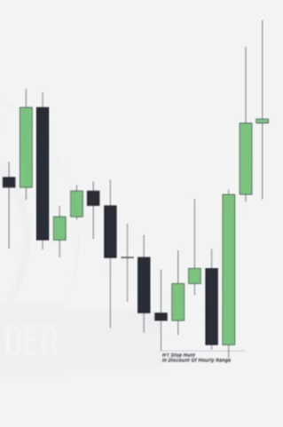

Going to the 5 minute chart

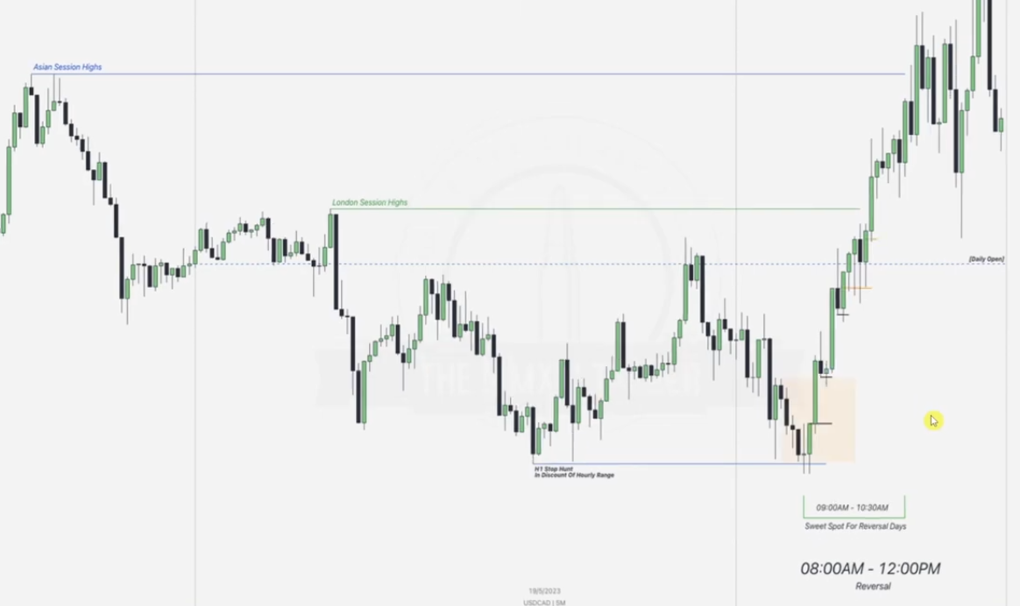

Draw out the 00:00 vertical lines, midnight open and the 8AM vertical line.

Notice that the london session has the high formed but there is distribution to selling within it, hence it is important to note the London high and asian highs as the next possible targets fro reversal.

Reversal is monitored to be done by taking out the hourly stop hunt in the NY killzone.

Bread and butter time line for NY reversal is btn 0900AM to 1030 AM except when there is high impact news.

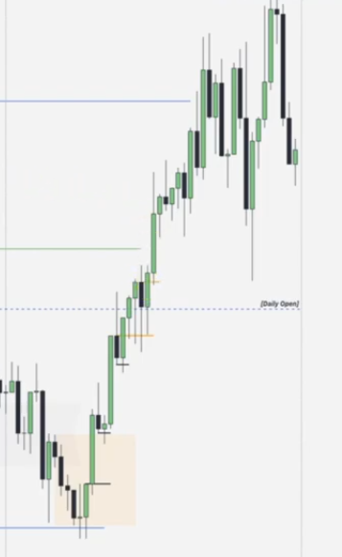

After the reversal, our aim is now to get bullish PD arrays.. eg order blocks that will be used as our points of entry while placing in more confluences.

EXAMPLE TWO REVERSAL

Given a five minute chart with 00:00 and midnight open drawn

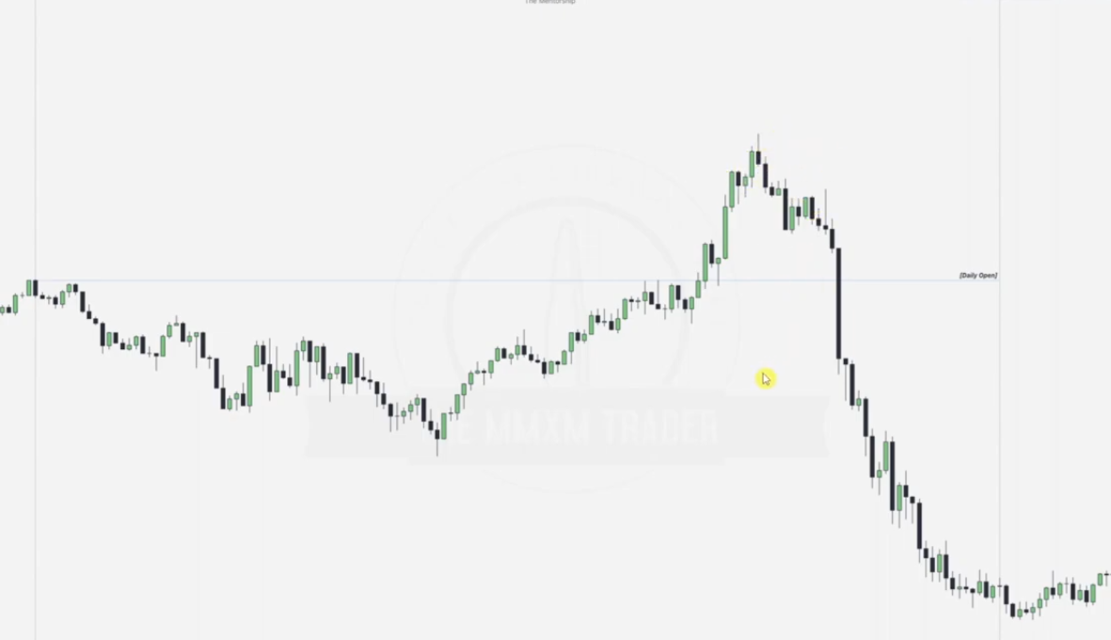

Draw the 8AM line and note the failure swings and the london session low as the liquidity points for the possible reversal.

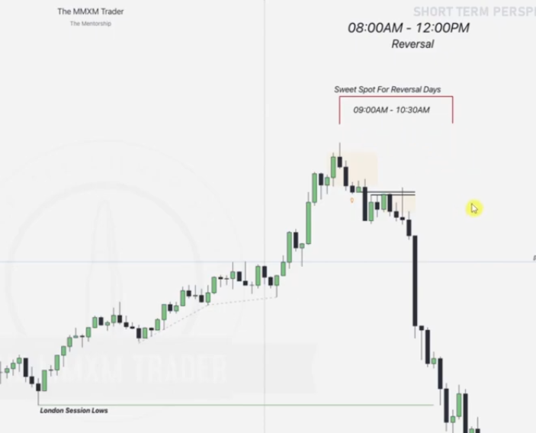

At our sweetspot 0900-1030am(except when there is high impact news) is where we start making plans for entry. THIS II A TRICKY ONE. Note the first order block formed supporting price lower, as price goes low a premium FVG is formed and another up-close Order block is formed just below it making it many confluences to support price lower... entry is good here..

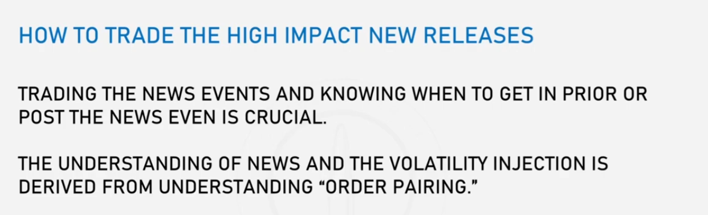

Order pairing as in take out a stop hunt or PD array and wait for a break in structure

### ****Order Pairing at the News Event****

#### ****Bullish Scenario:****

**When Sell Stops Have Already Been Taken:**

If the market has already cleared **significant sell stops** before the news session:

The news event will likely trigger a **single directional move upward**. This movement pairs with the existing **buyside liquidity (buy stops)..failure swings** that were engineered before the session.

**When Sell Stops Have Not Yet Been Taken:**

If the market has not cleared **significant sell stops** before the news session:

The news event might create a **fake move (known as a Judas Swing)**.

This fake move will target **sell stops** in the market.

The price may reach an **external range low** or **internal range low**, accumulating the necessary **sell stops**.

After the fake move, the market reverses and moves higher to target the **existing buyside liquidity (buy stops)** resting in the market... order pairing done

### ****Order Pairing at the News Event****

#### ****Bearish Scenario:****

**When Buy Stops Have Already Been Taken:**If the market has already cleared **significant buy stops** before the news session: The news event will likely trigger a **single directional move downward**.This movement aligns with the existing **sellside liquidity (sell stops).. failure swings** that was engineered before the session.

**When Buy Stops Have Not Yet Been Taken:**If the market has not cleared **significant buy stops** before the news session:

* + 1. The news event might create a **fake move (Judas Swing)**.
    2. This fake move will target **buy stops** in the market.
    3. The price may reach an **external range high** or **internal range high**, accumulating the necessary buy **stops**.
    4. After the fake move, the market reverses and moves lower to target the **existing sellside liquidity (sell stops)** resting in the market.

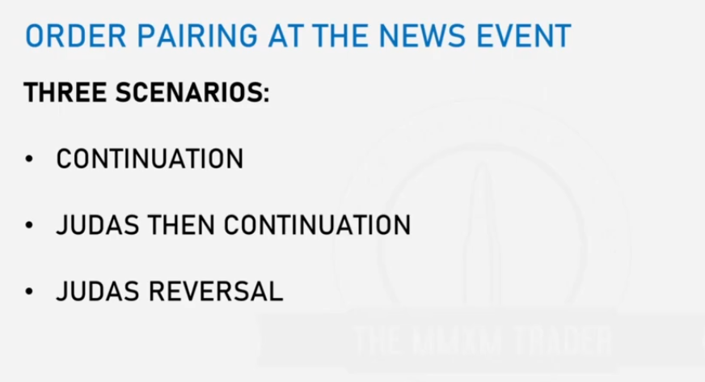

CONTINUATION

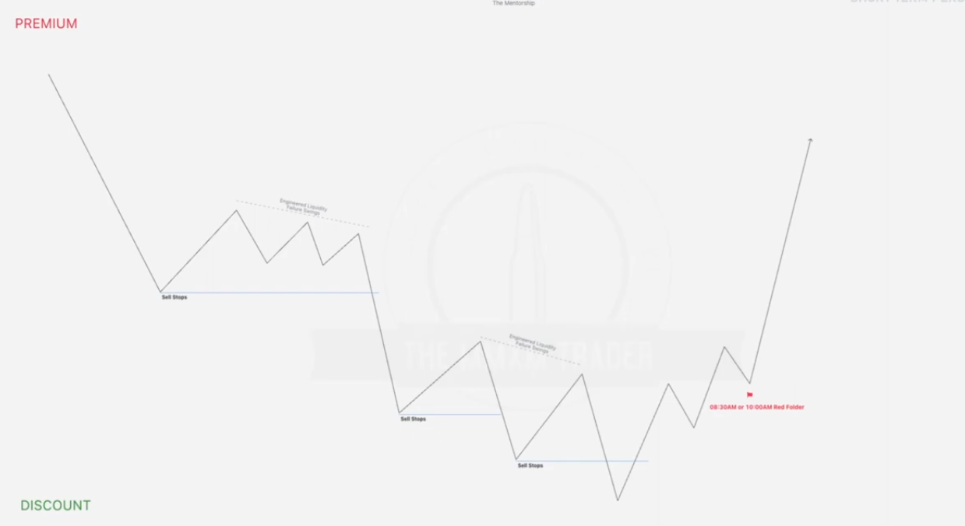

Note the Failure swings.. Buy stops and the sell stops and whether these sell stops are being taken.

Note that the news comes after the last sell stops have been accumulated-- order pairing and there are no sell stops left to take out hence highest probability is it taking out the Buy stops at the Failure swings. Hence continuation after the news event.

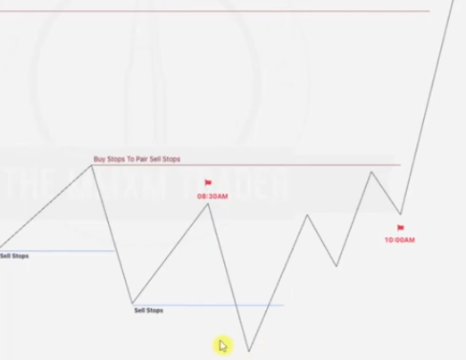

Consider from same graph that news occur before last significant sell stop... inorder to take this the news causes formation of a judas swing

Bearish scenario

News after order pairing... continuation

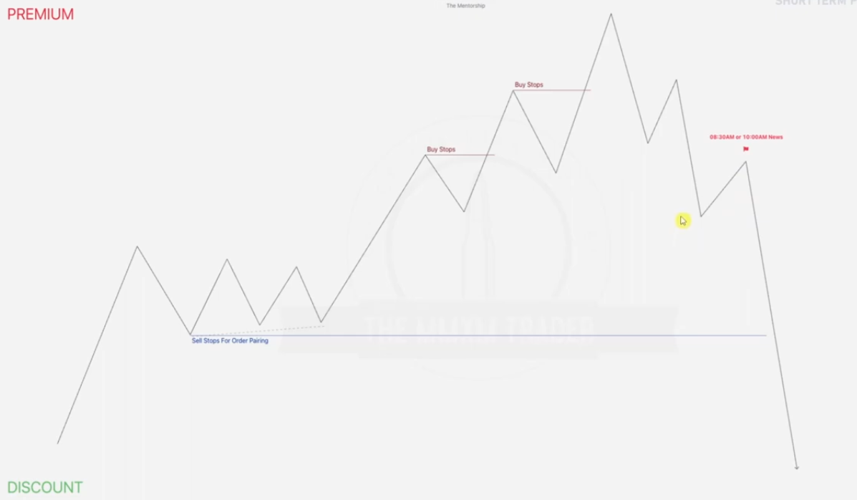

News before order pairing.. Judas swing

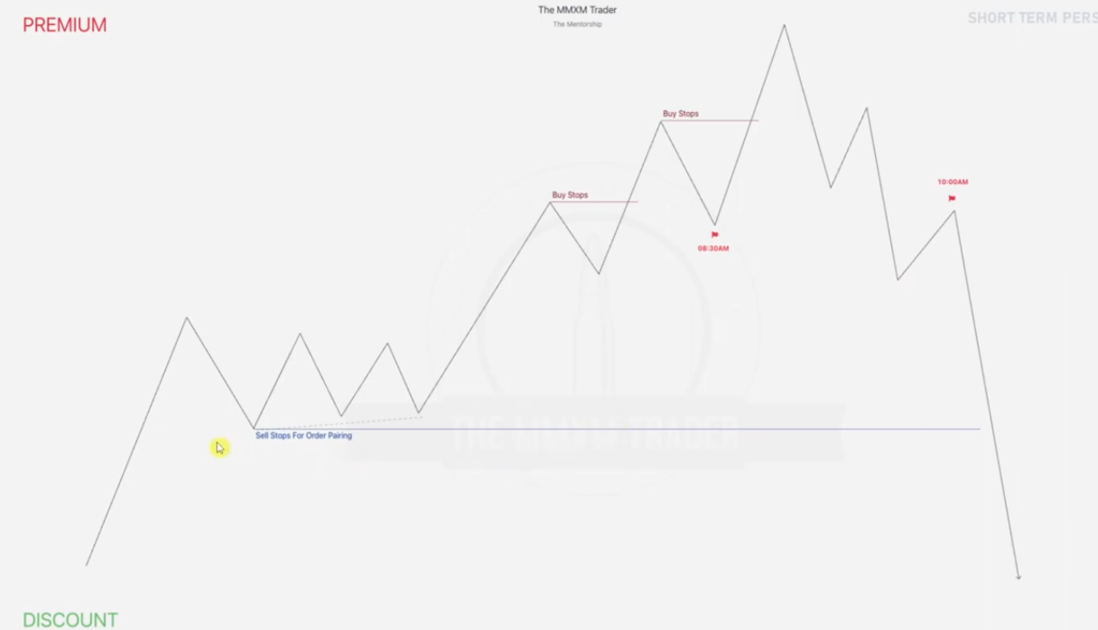

EXAMPLE 1

Given a daily chart

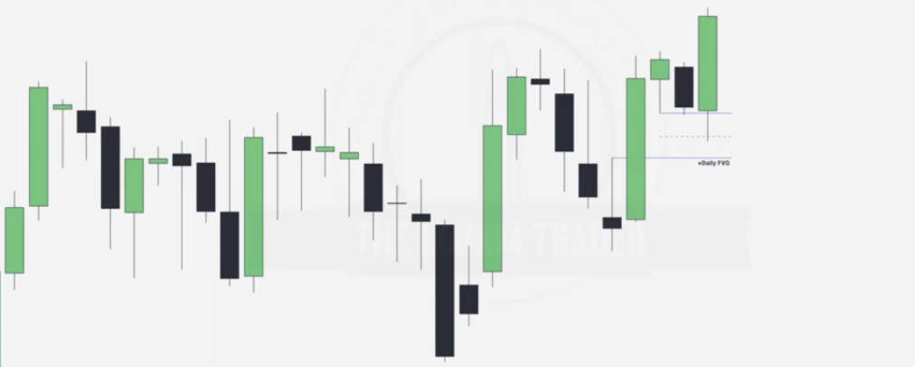

With ERL V IRL, we go from daily to hourly hence we go to hourly structure now

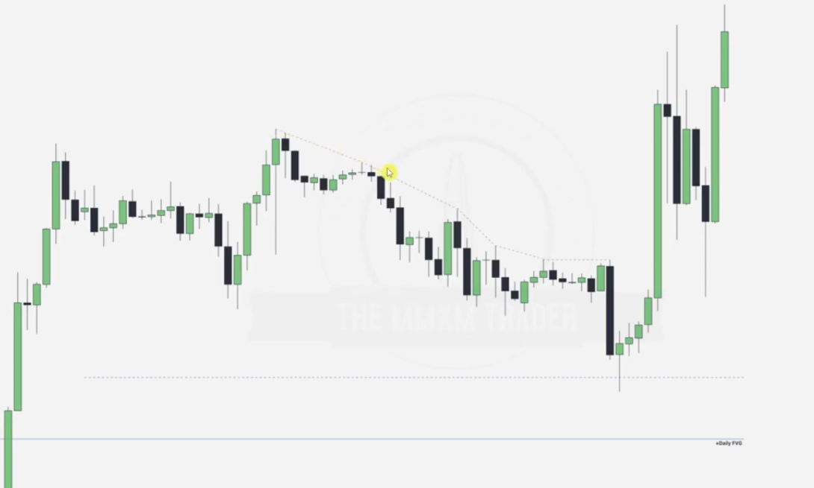

First step is to spot our engineered liquidity.. failure swings... then next to spot the sell stops(since this is MMBM) and wait to note where out order pairing will take place

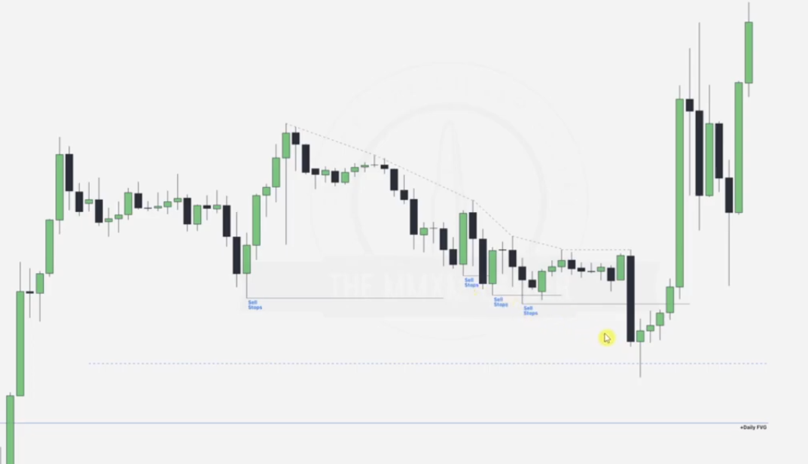

Provided all these sell stops are raided prior to the news release.. lets go to a 5 minute chart.. from 1hr to 5 minute

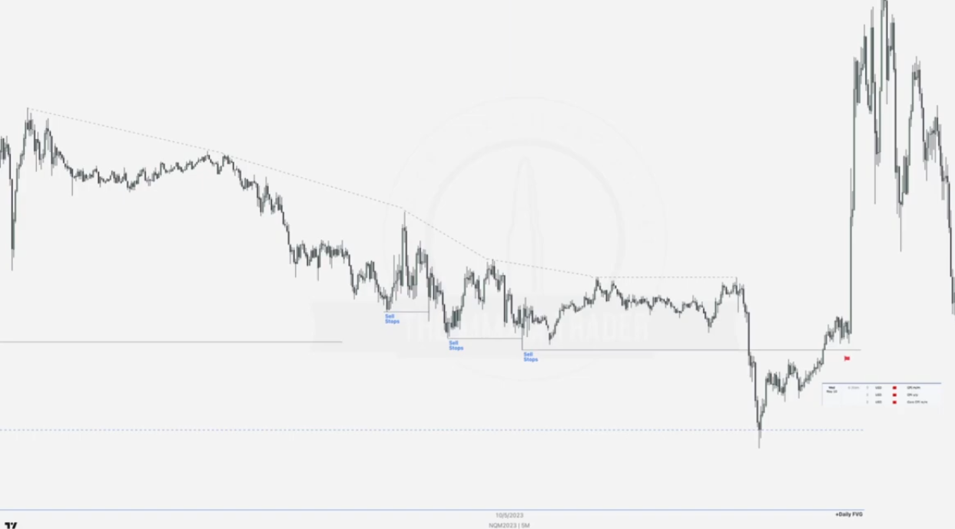

Note that the sell stops are being taken prior to the order pairing and during the order pairing we tend to tap into the daily FVG... the high impact news comes just above the pairing from which we can anticipate a continuation.. trying to take out the engineered liquidity levels.

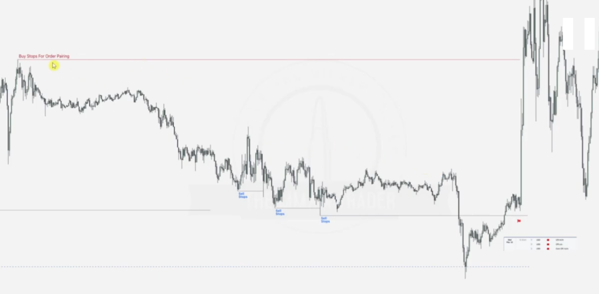

We can draw the buy stops as above

Given this

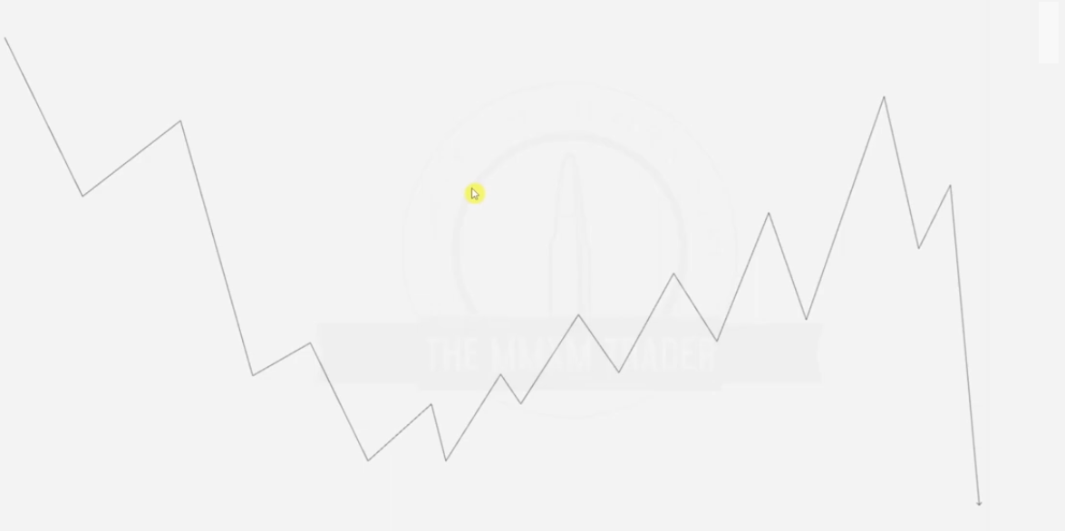

First step is to determine the engineered liquidity, then draw the order pairing.. buy stops being taken out to form..

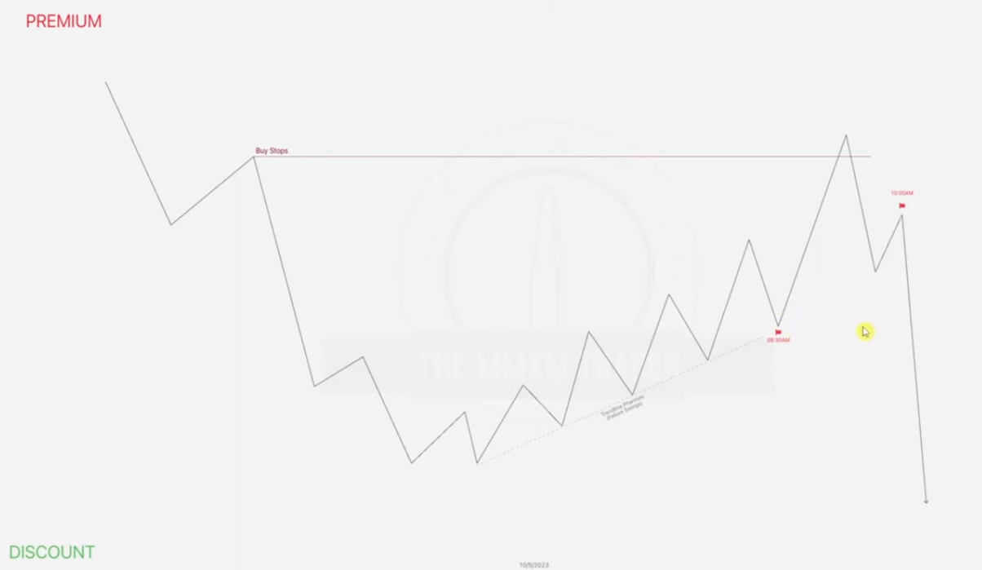

Note that if the high impact news comes after the Buy stops have been taken, it will directly start hunting for the engineered liquidity without a Judas swing while if it comes before the buy stops have been taken , it will create a Judas swing before aiming for the engineered liquidity.

EXAMPLE

Given daily chart with buy stop labeled

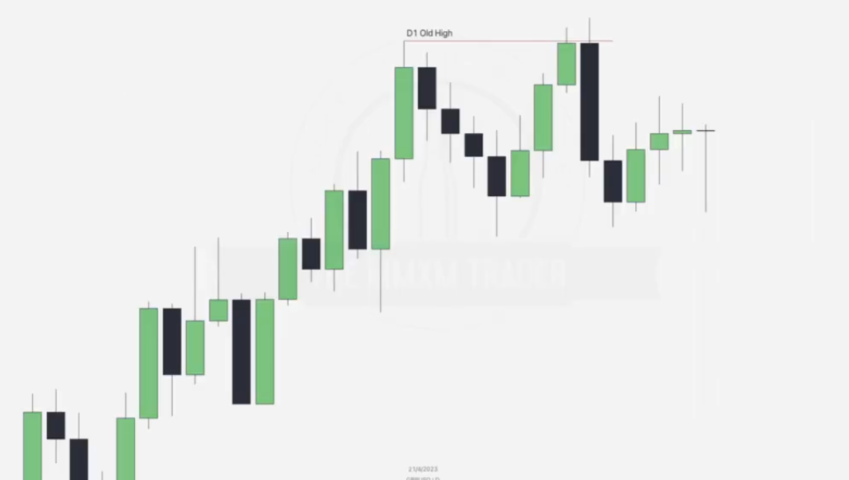

Note that from here we have ERL taken.. from there next step is IRL.. FVG formed in process to take the ERL.. after this initial FVG is taken , we take out another ERL.. SSL and form a new FVG.. as below

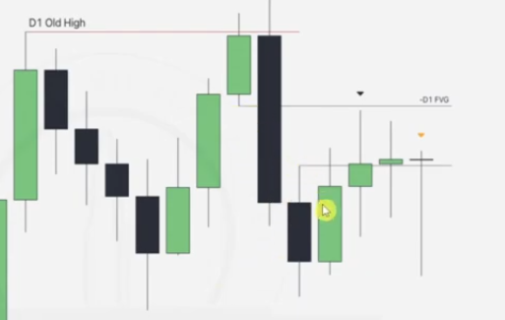

Going to the hourly chart

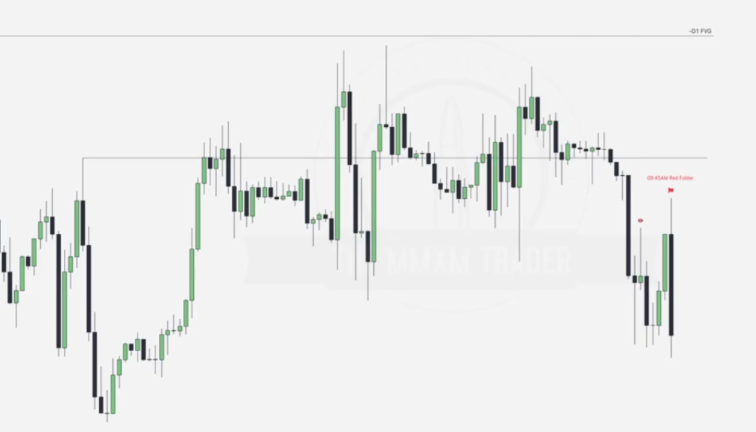

Note that the FVG is providing resistance, at the point where the news happens, we have a buy stop labeled with the eye which has not been taken yet... are we bullish or bearish.. remember FVG is providing resistance.. as a result the wick forms a Judas swing to take out this buy stop and continue short after..

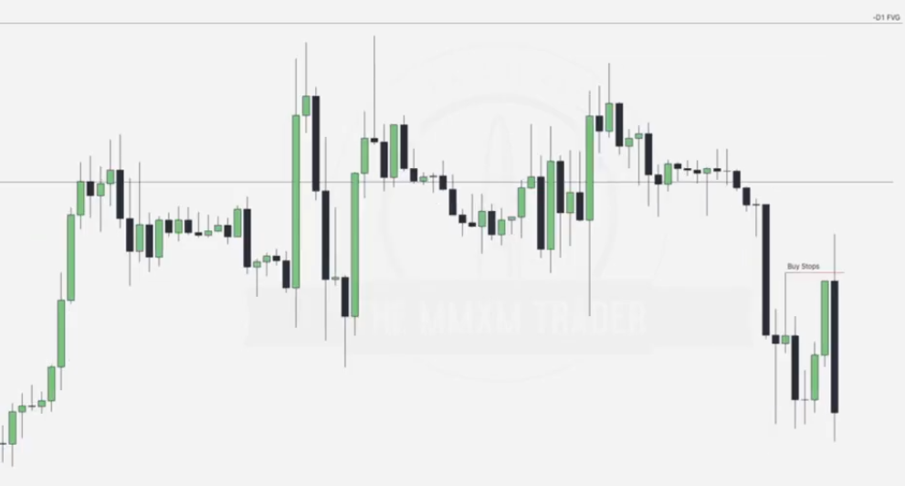

Going to the one-minute chart.. note the buy stops and sell stops forming order pairing and the engineered liquidity

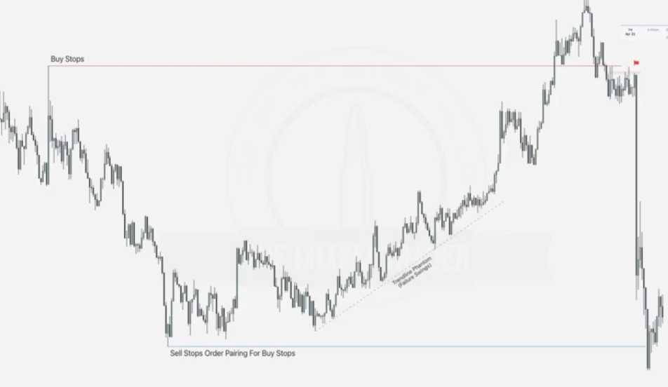

After the reversal before the buy stops.. at accumulation of stops.. note that this FVG formed is respected hence forcing price downwards

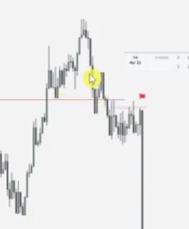

Note another FVG pushing price even lower.. before an accumulation happens

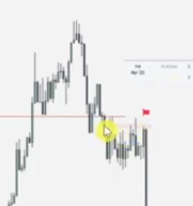

This shows that we should anticipate for price to take out the failure swings or the sell stops as first labelled..

Looking at the execution picture.. we are going to focus on the pointed among the many

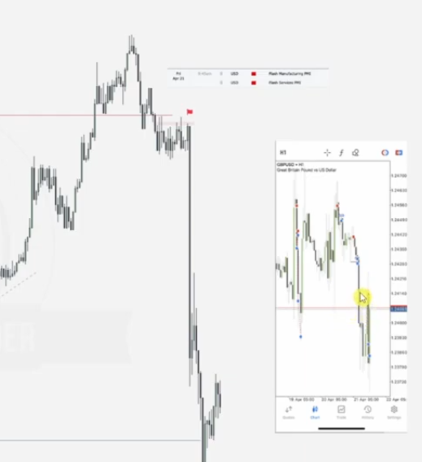

This denoted this sell execution at the accumulation point... showing we can enter around here when the expansion begins

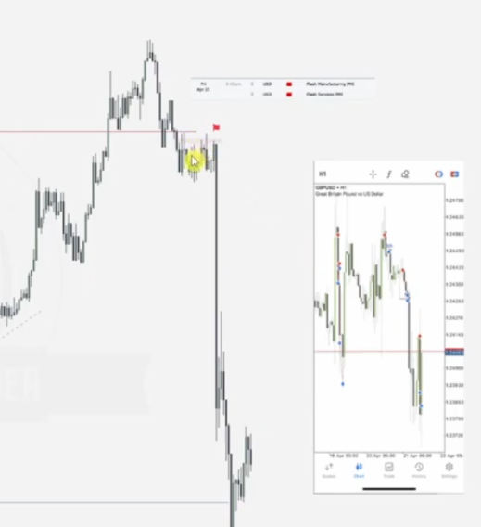

An **execution picture** refers to the visual and logical setup a trader uses to determine when and where to enter or exit a trade. It is essentially the framework or set of conditions that aligns with the trader's strategy to "pull the trigger" on a trade. It helps ensure precision and consistency in execution by defining key elements of the market at the time of action.

### Components of an Execution Picture:

* **Market Context**: Understanding the current phase of the market (e.g., trending, ranging, consolidating).Alignment with the higher time frame narrative (e.g., bullish/bearish bias or liquidity draw).
* **Liquidity Zones**: Key levels such as **external range liquidity** (e.g., swing highs/lows) and **internal range liquidity** (e.g., fair value gaps, order blocks).
* **Confirmation Signals**:Candlestick patterns (e.g., engulfing, rejection wicks)...Structural shifts (e.g., market structure breaks or retracements into premium/discount zones).
* **Kill Zones (Time-Based Execution)**: Specific sessions like **London Open**, **New York Open**, or other predefined time windows with high probability setups.
* **Risk Management Factors**:Stop loss placement (e.g., above/below liquidity zones)...Risk-to-reward ratio.
* **Confluences**: Multiple technical factors aligning (e.g., Fibonacci levels, order blocks, liquidity sweeps, etc.).

### Purpose of an Execution Picture:

### **Precision**: Avoids impulsive entries by adhering to a strict set of conditions.

### **Consistency**: Provides a repeatable process for trade execution.

### **Efficiency**: Saves time by focusing only on high-probability setups.

EXAMPLE

Given a daily chart

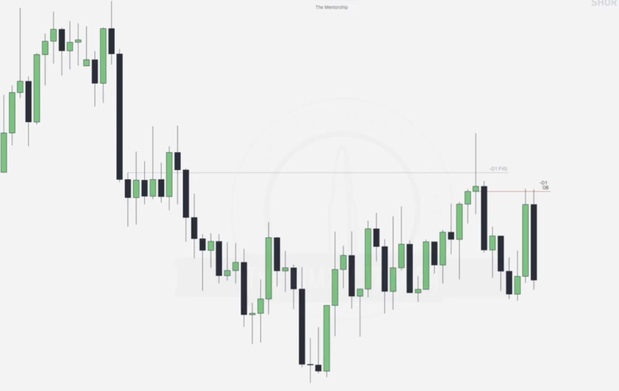

Notice the first FVG drawn halfway and the OB formed which touches the first FVG noted... hence high probability.

From looking at these two PD arrays which are in premium zone we see that they are being respected hence we aim for bearish market and note our failure swings.

Going to the hourly chart

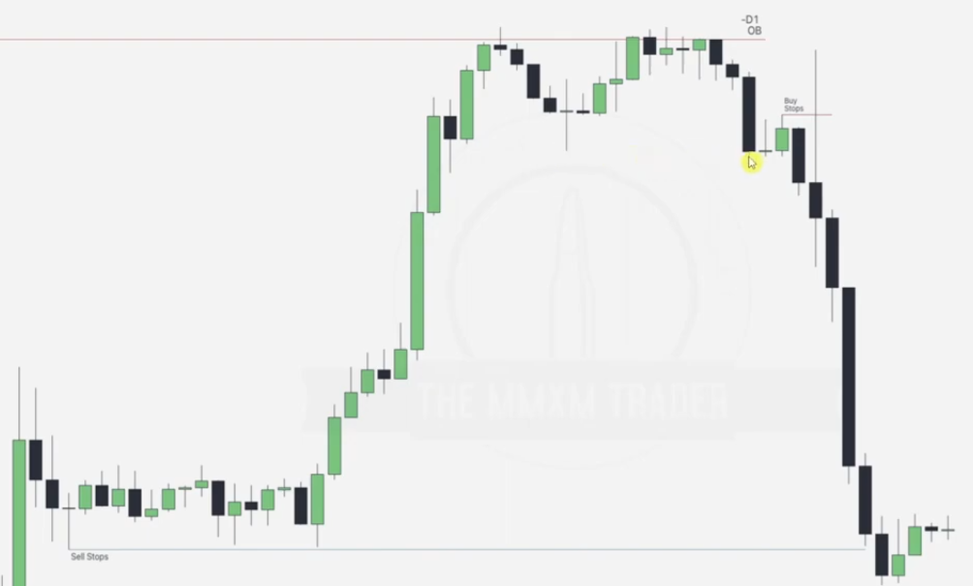

Note the OB being respected and there is a Buy stop which price comes to tap in before continuing bearish.

Going to the 5 minute chart

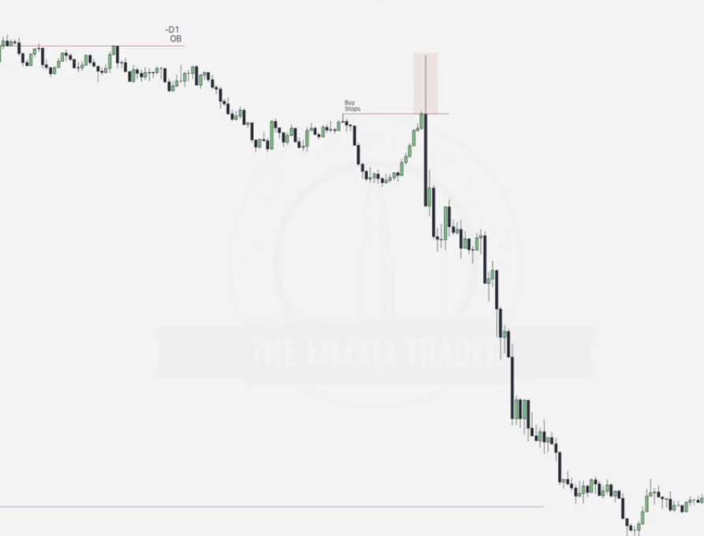

Note that if news occurs just at the point where buy stops are taken, it has taken a judas swing to take out the buy stops and continue downwards.. if another news occurs after this the logical thing is that it will continue downwards.. hence try to trace out further entries

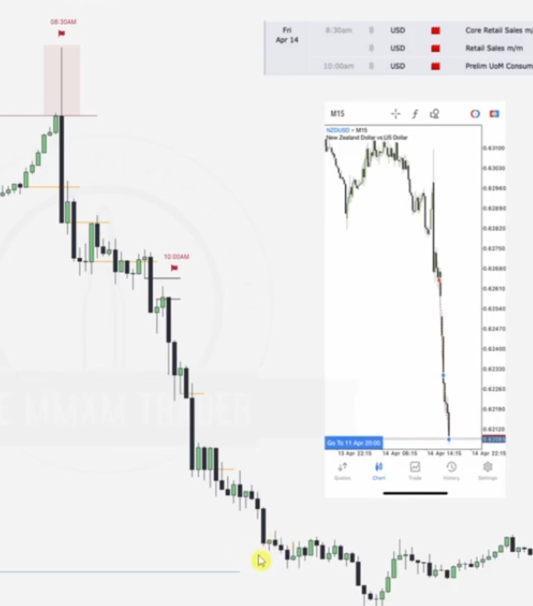

News that occurs at 1000am tap into an FVG which is respected in the process hence this is a good point for entry, also note out the up-close OBs which are respected as above .. check out which are High probability and they can also be entry points.

EXAMPLE (NEWS RELEASE GIVING A FULL BLOWN REVERSAL)

Given a monthly chart

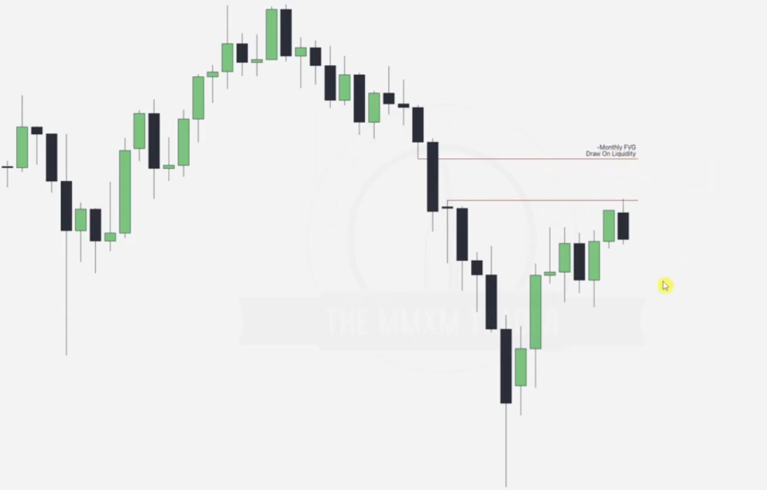

Going to the daily chart

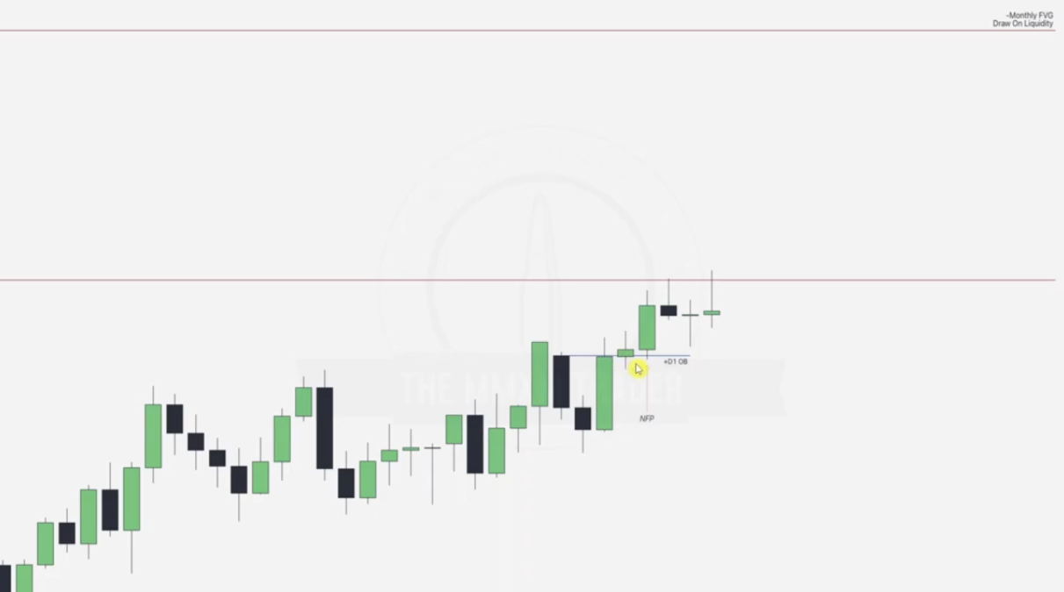

n this case, the **first bearish candle** is marked as the order block because it is likely considered the **origin of the last significant bearish move** before the market reversed and broke structure to the upside. Here's why the second bearish candle is not marked:

### Characteristics of the First Bearish Candle:

**Last Down Move Before the Up Move:**

* 1. The first bearish candle represents the final push down (selling pressure) before buyers stepped in and pushed the price higher, indicating a potential **demand zone**.

**Institutional Activity:**

* 1. Order blocks are often areas where institutional traders (banks or large market players) accumulate or execute their orders. The first bearish candle reflects where selling may have been absorbed before the bullish move started.

**Market Structure Break:**

* 1. If price moved significantly higher after this bearish candle, breaking previous highs or structure, it confirms that this candle's level holds importance as a **pivot point**.

### Why Not the Second Bearish Candle?

**Proximity to the First Candle:**

* 1. The second bearish candle may have been part of the consolidation or overlap with the first candle's price action, making it less distinct.

**Less Relevance:**

* 1. The second bearish candle might not represent a fresh area of interest because price had already begun its reaction at the level established by the first bearish candle.

**Volume and Price Action:**

* 1. The first candle could have more volume or represent a more significant shift in order flow compared to the second candle, which could be seen as noise.

### In Practice:

Traders typically mark the **most relevant order block** based on:

* Market structure.
* The significance of the price reaction.
* The efficiency of price delivery (e.g., the presence of fair value gaps or imbalances).

Would you like a deeper explanation or a diagram to clarify further?

Going to 15 minute chart

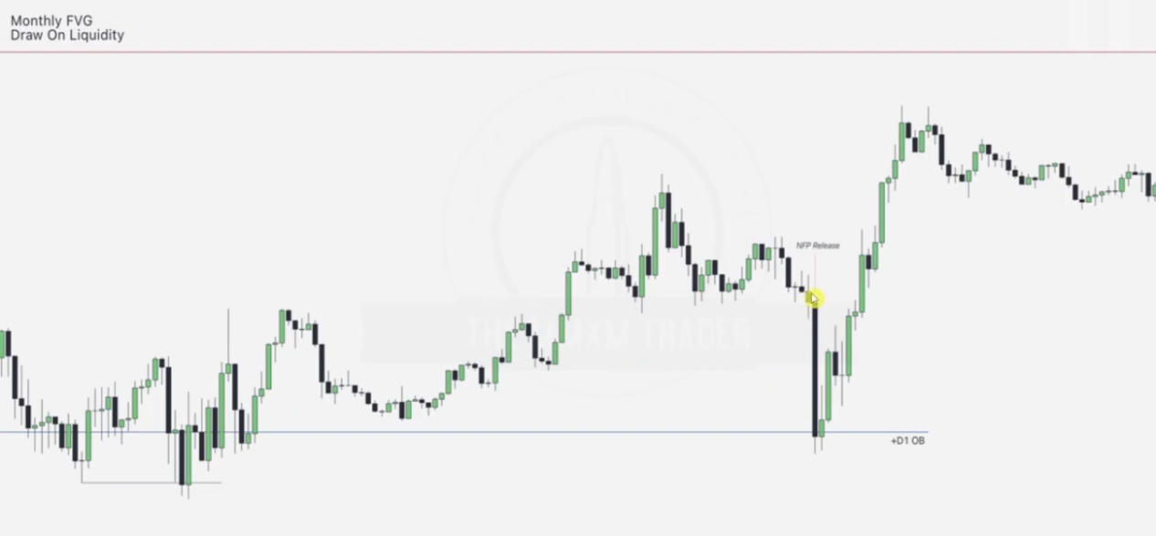

Note that before the reversal there were significant sell stops waiting to be taken.. engineered liquidity and the OB as the next IRL

Conditions applied for reversal here are as below.. we can also apply else where

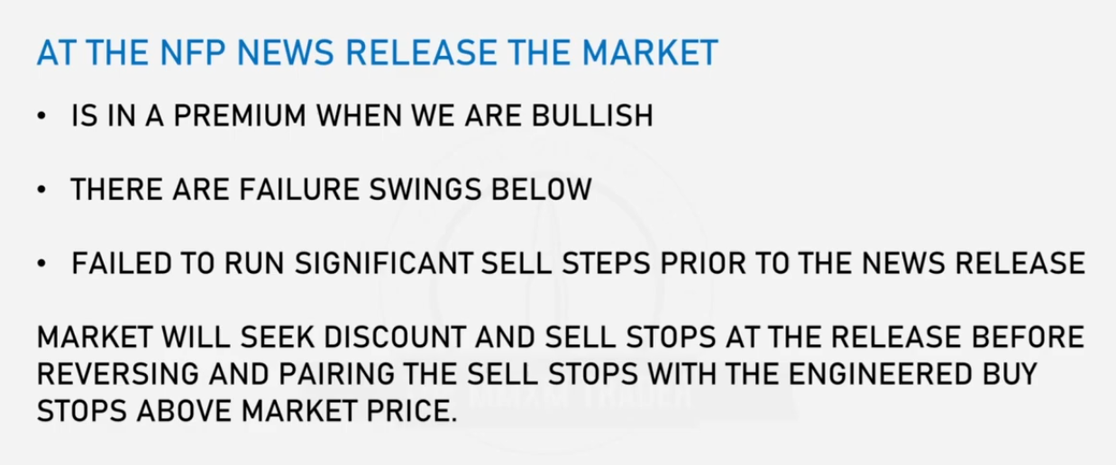

Adding more lipstick to the chart

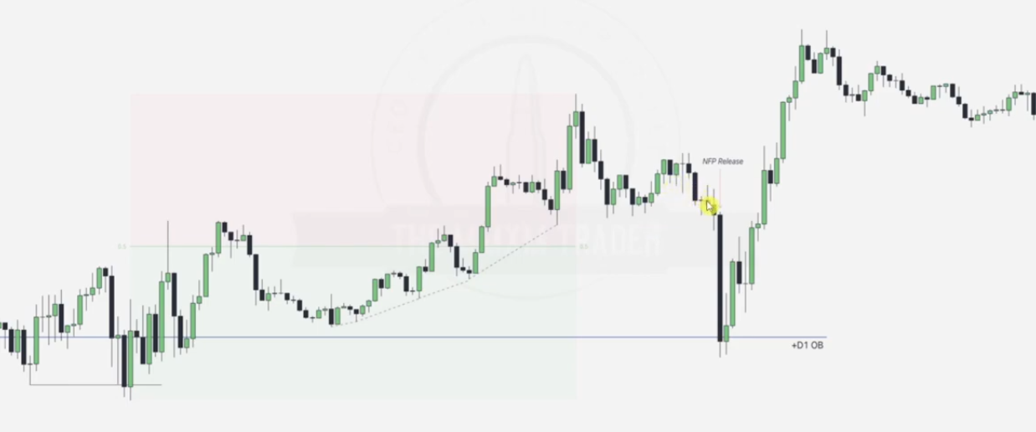

After the sell stops are taken.. note the order pairing

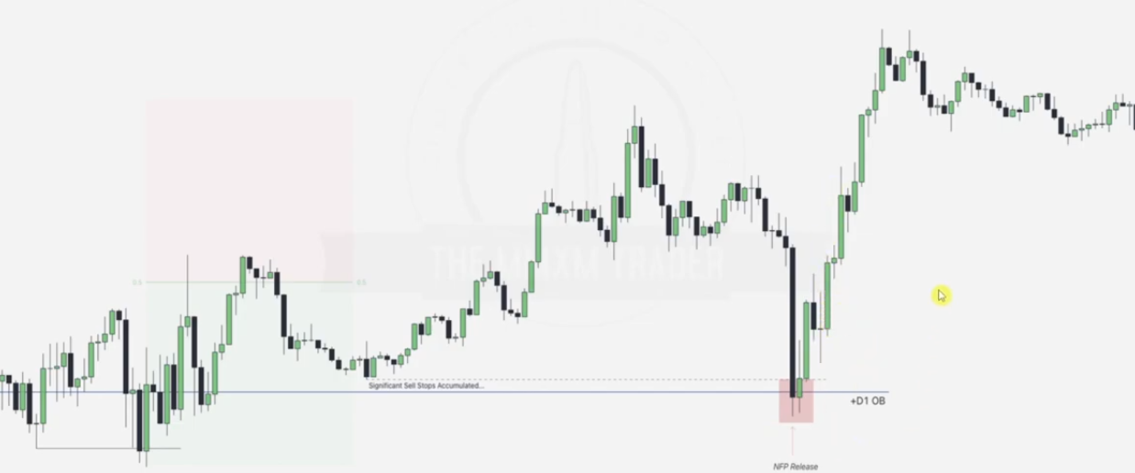

Note the buys stops, main aim is the draw on the monthly FVG above

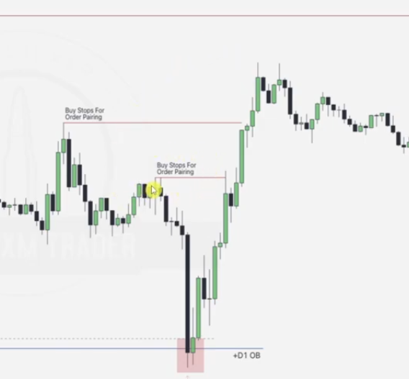

PUTTING IT ALL TOGETHER

Involves analysing a chart at Long term perspective(Monthly, weekly, daily).. intermediate term perspective(4hr, 1hr) and to lower term perspective(15min to 1 min)

EXAMPLE 1

Given the daily chart

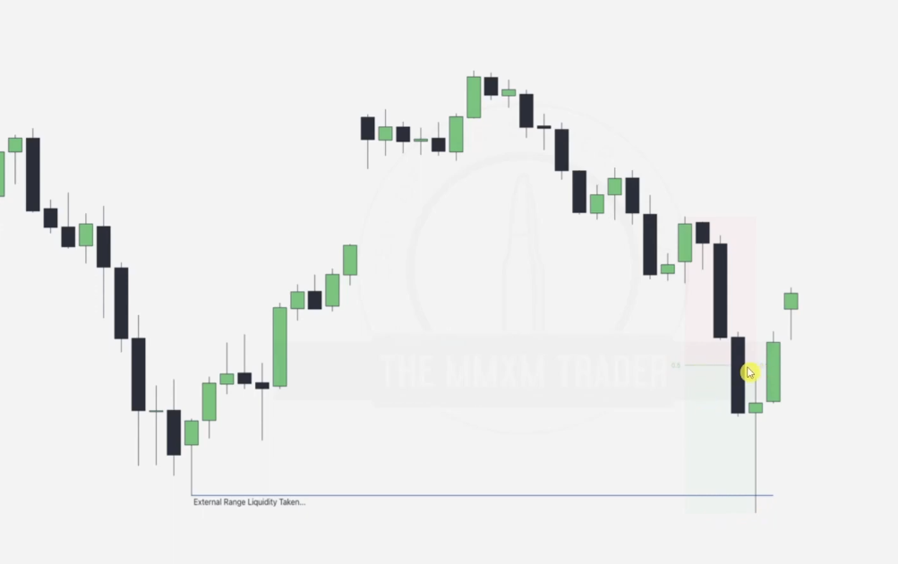

LTP

Draw prem-disc and label Daily premium FVG for ERL Vs IRL. Meanwhile also note the order pairing done at the sell stops before aiming for the daily premium FVG.

Next draw is the FVG as shown, LTP predicts that next aim is the premium FVG

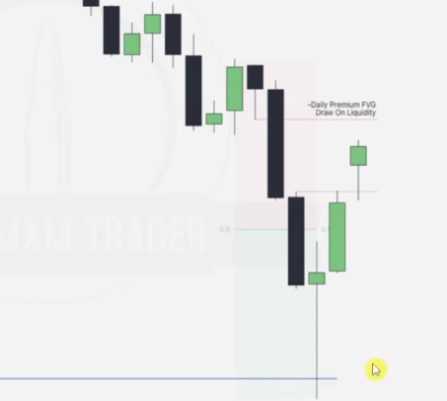

ITP- Going to 1 hr chart

Aligning ITP and LTP helps us be on the right side of the market while we can use STP for entry.

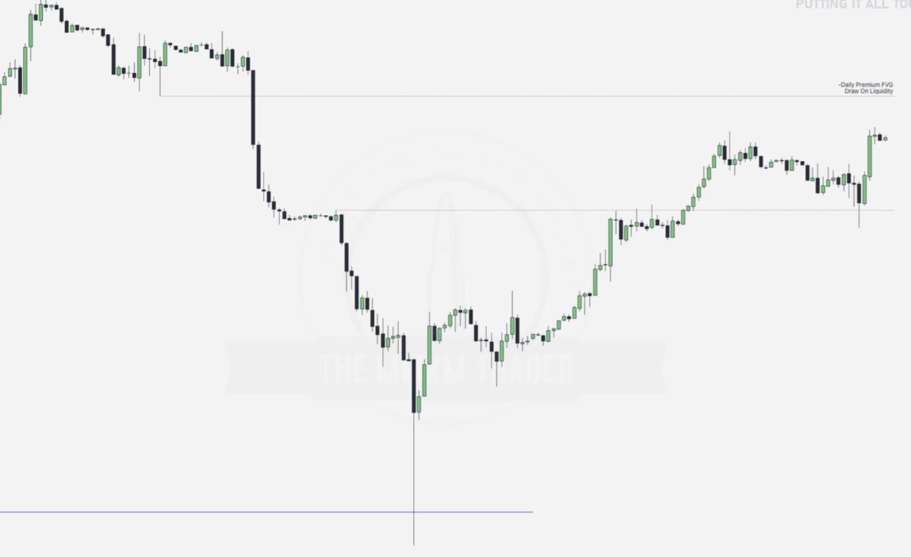

Main aim here is to determine the alignment of ITP and LTP, after order pairing we wait to determine if there is a break in structure to show that market is now bullish and aiming for the LTP premium FVG. This is seen after the ERL... failure swing is taken as below

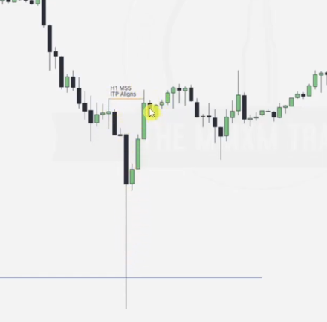

As a result LTP aligns perfectly with ITP

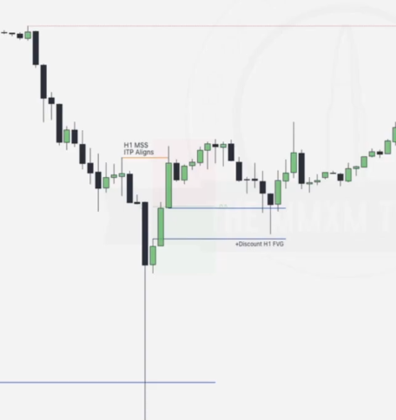

STP - Determining whether 8-12 am killzone will have continuation or reversal

Going to the 5 minute chart

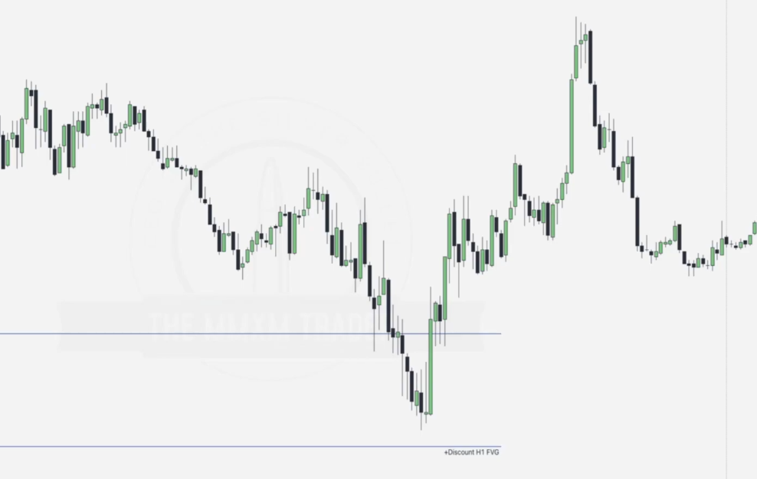

Best place to look at is the order pairing part.

Note down the Failure swings , midnight open and the london session high.. since we note down the order pairing around 8-12 am timeline and rest of the day has been bearish while LTP and ITP align to bullish setup.. we expect a reversal at 8-12 am hence our target for the ERL can be the london session high... and as a result 8-12 AM will present a REVERSAL....

Label the break of structure(taking out ERL) after the order pairing as below

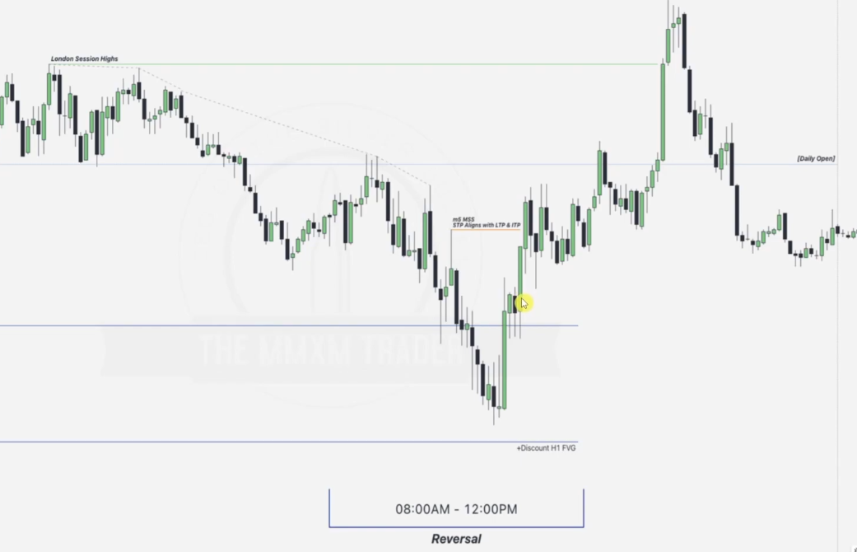

Netx step is to mark the following entry points as OBs.. make sure these entry points are within the 8-12 AM

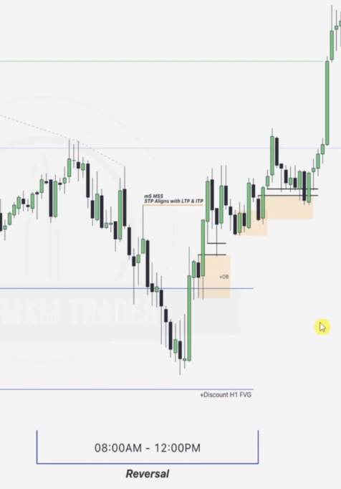

You can also include mitigation blocks

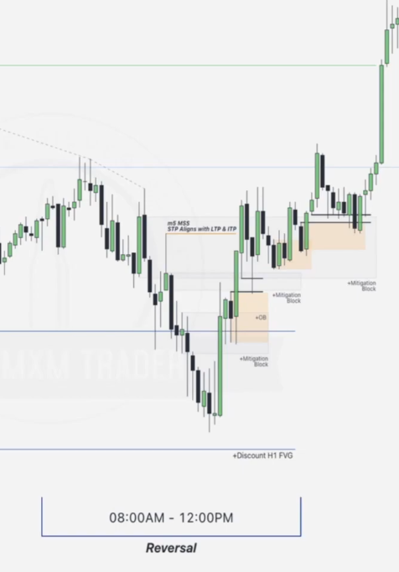

EXAMPLE TWO

Given a weekly chart

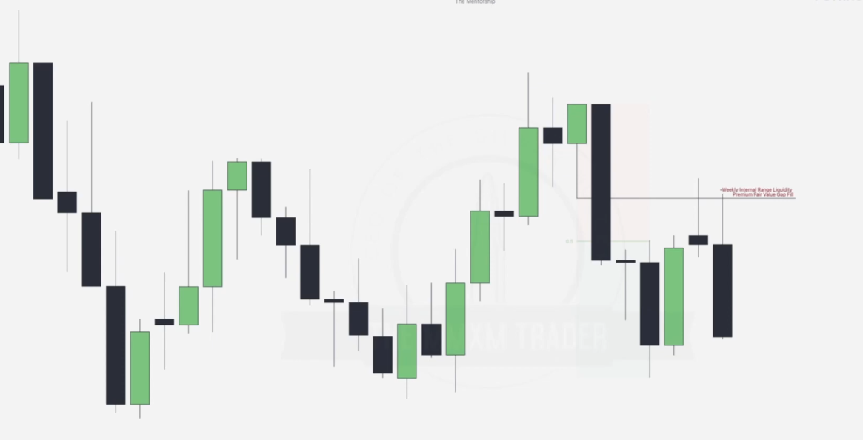

LTP

Draw prem_disc

Note that there is a FVG fill, IRL taken hence next is ERL spotting and drawing as below

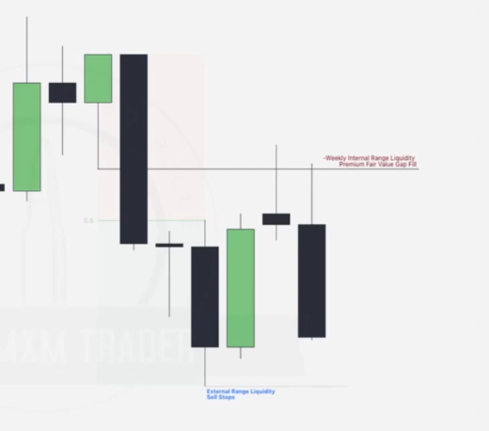

ITP- confirming bullish intent of LTP

Going to the 4hr chart

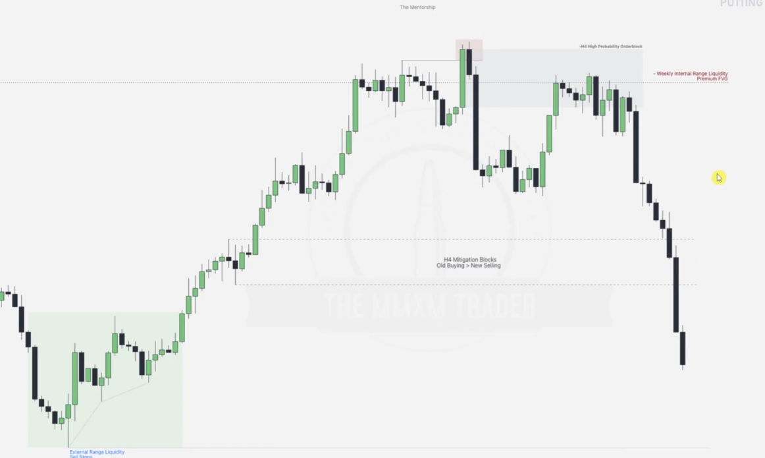

Note the order pairing and wait for the break in structure to confirm the alignment with LTP

Note the up-close order block and the mitigation blocks as aligned to help with entries when in lower time-frames

STP

Going to the 15 minute chart, we draw the midnight open.. and our next question to be answered is .. is 8-12am continuation or reversal

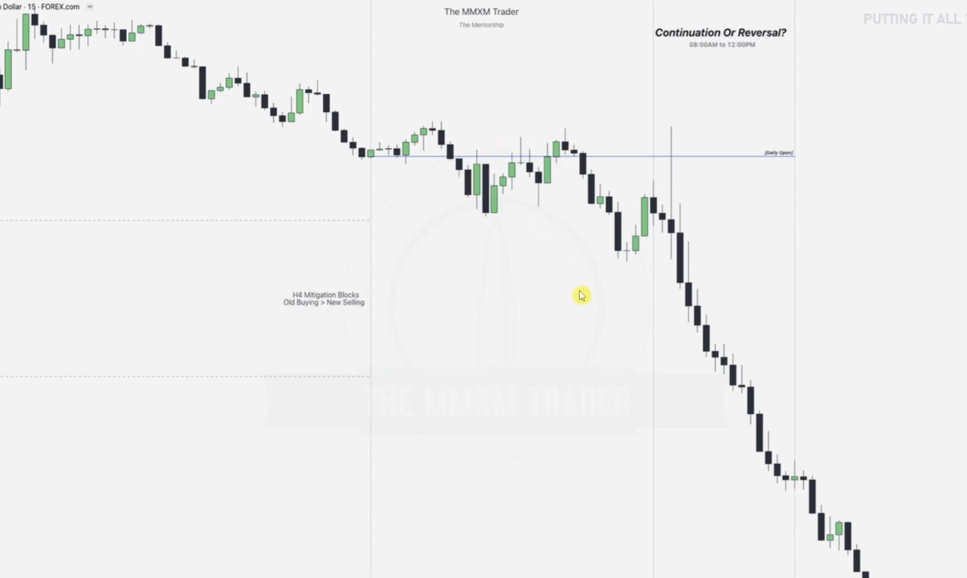

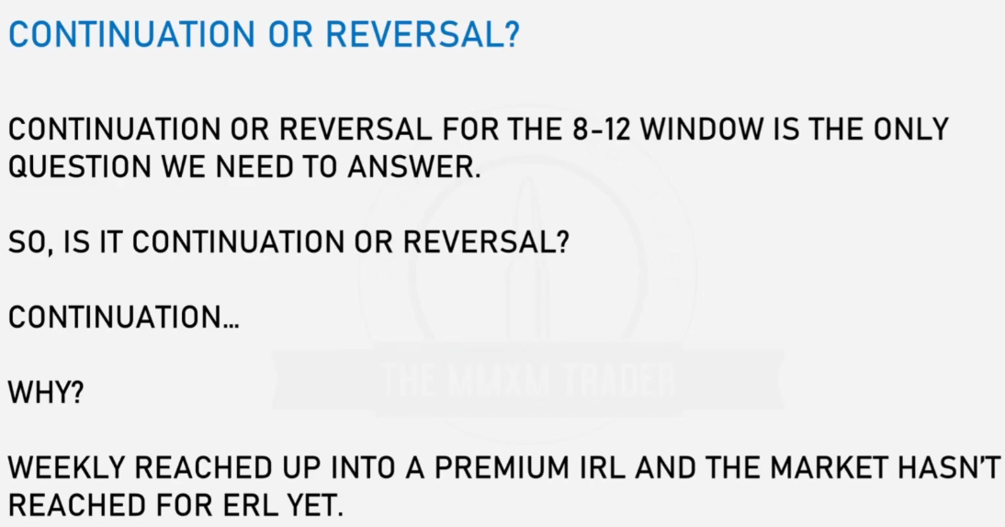

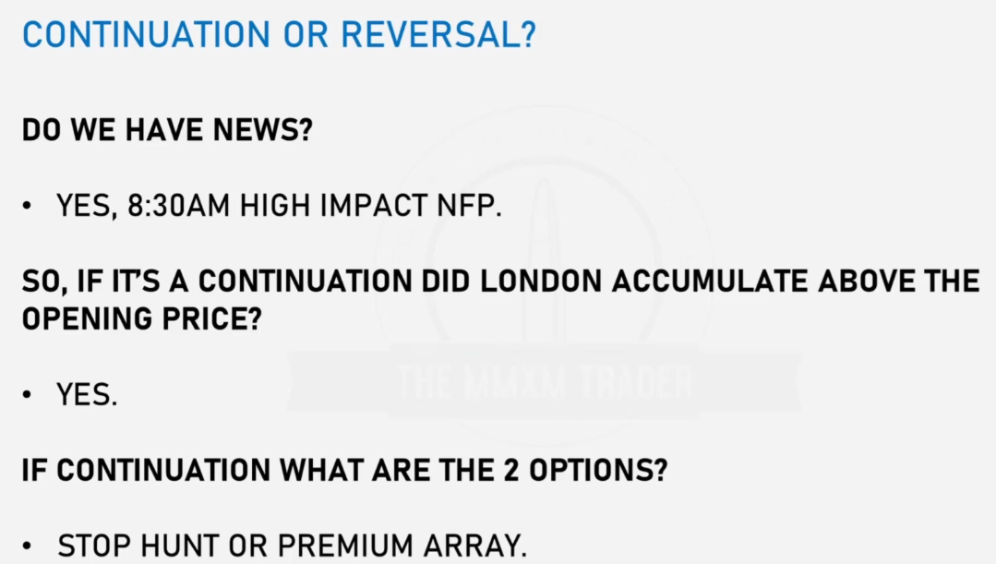

Note the news time as below... when the news arrives is there a premium array tapped.. or a stop hunt taken?

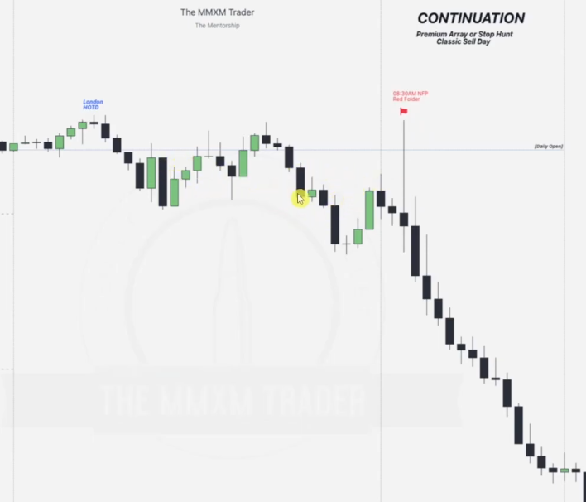

Note that the news causes sell program to be activated hence we wait for a break in structure and from here onwards all up-close candles should support price downwards..

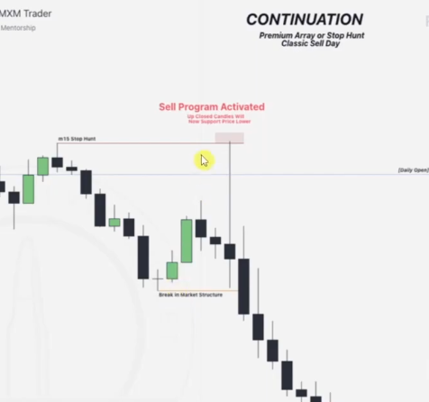

We are able to see only one up-close candle here for entry.. we could go into a lower time-frame for better entry

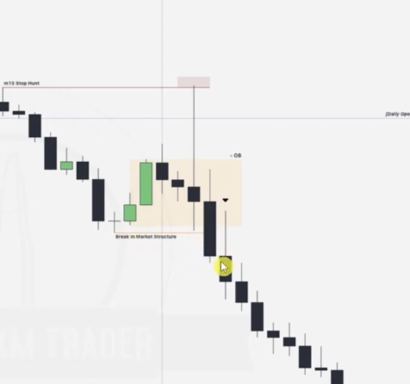

Going to 5 minute time-frame

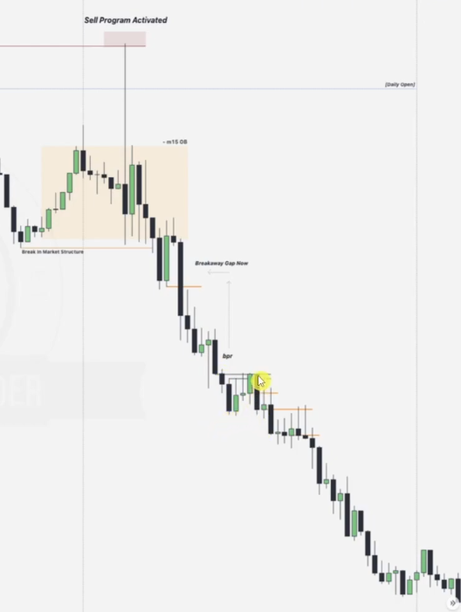

We are able to draw the up-close candles more importantly.. BPR is noticed with break way gap.. THIS IS VERY IMPORTANT TO NOTE THAT THERE IS NO RETRACEMENT TO THE FVG TO COME.... PLEASE LIST DOWN ALL FVGs FOR CONFLUENCES LIKE THIS.. EG FVG FILL TOO.

REMEMBER THE FINAL DRAW TO ERL was drawn in the weekly chart..